|  |
| --- |
| **Written By:**  **VenuYerra (**[venu.yerra@ideaentity.com](mailto:venu.yerra@ideaentity.com)**)** |
| **COMPTROLLER SERVICES PORTAL-USER MANUAL FOR CPTS CSR MANAGER ROLE** |
| **Submitted To:** |
| **Submitted By:** |
| **Written By:**  **VenuYerra (**[venu.yerra@ideaentity.com](mailto:venu.yerra@ideaentity.com)**)** |

[](https://ideaentity.sharepoint.com/sites/CSPtest/42cpts)

Table of Contents

INTRODUCTION 4

NAVIGATE TO CSP PORTAL HOME PAGE 4

NAVIGATE TO INQUIRIES PAGE AS CPTS CSR MANAGER 8

FEATURES IN INQUIRIES HOME PAGE FOR CPTS CSR MANAGER 9

INQUIRY SEARCH 10

ALL INQUIRIES TILE 11

TOTAL INQUIRIES TILE: 11

DASBOARD SECTION: 12

EXPORT TO EXCEL: 14

UNASSIGNED TILE: 15

ASSIGN INQUIRIES BY SELF 16

ASSIGN INQUIRIES TO ANOTHER MANAGER 18

CATEGORY CHANGE: 19

By selecting the “Self” radio button: 19

By Selecting the “Other” radio button: 21

ELEVATE INQUIRIES TO CPO/AFIMSC 23

INQUIRIES IN ACTIVE TILE: 25

CLICK THE ASSIGN TO ME status: 25

ASSIGN INQUIRY TO ANOTHER CPTS CSR MANAGER 26

ELEVATE INQUIRY TO CPO/AFIMSC 28

DASHBOARD SECTION (when ACTIVE Tile is in Active) 30

COMPLETED TILE: 31

OTHERTILE: 32

MY INQUIRIES TAB WORKLIST 32

TOTAL INQUIRIESTILE: 32

SAVED TILE: 33

INQUIRY REQUEST DETAILED VIEW PAGE 33

ADD DISCUSSION 34

ADD INTERNAL DISCUSSION 36

REPLY FOR THE DISCUSSIONS 38

SEARCH DISCUSSIONS 39

ADD FILES 40

DOWNLOAD DOCUMENT FROM THE FILES SECTION 43

DELETE FILE 43

DOWNLOAD ALLFILE 45

ADD TEAM MEMBER 45

DELETE TEAM MEMBER 46

CUSTOMER ACTION REQUIRED 47

RETURN INQUIRY TO CPTS 49

RESOLVE INQUIRY 51

CLOSE THE INQUIRY 53

REOPEN THE INQUIRY 55

CANCEL ACTION 57

DUAL ROLE: 59

# INTRODUCTION

Comptroller Services Portal (CSP) is an intranet portal facilitated to automate and standardize customer service procedures and decision support to streamline the data collection and analysis. The CSP design is as such to meet the Timely and accurate pay for and personnel transactions throughout Air Force wide. Currently there is way to capture information and statistics for, finance customer service areas. Air Force FM Leadership has visibility into what Customers are seeking help for.

# NAVIGATE TO CSP PORTAL HOME PAGE

1. Login into the site using respective **CPTS CSR Manager** credentials
2. Portal home page displays for **CPTS CSR Manager**.

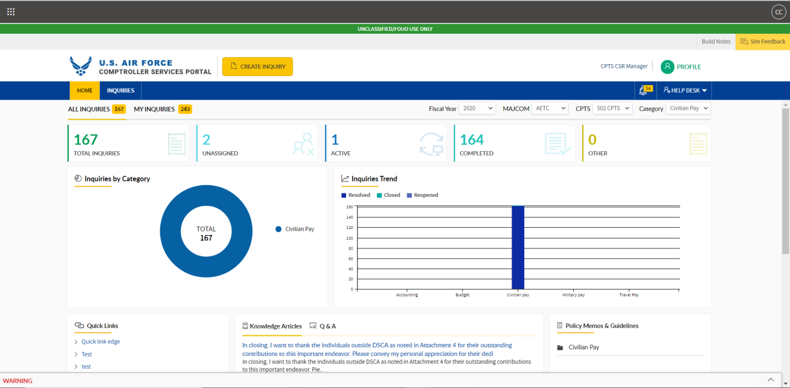

1. Based on the respective **CPTS data** will visible.



1. In CPTS dropdown need to display only the active **CPTS**.

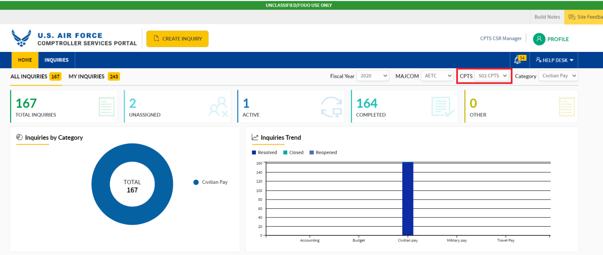

1. Login with respective CPTS need to auto populate related **MAJCOM** in dropdown

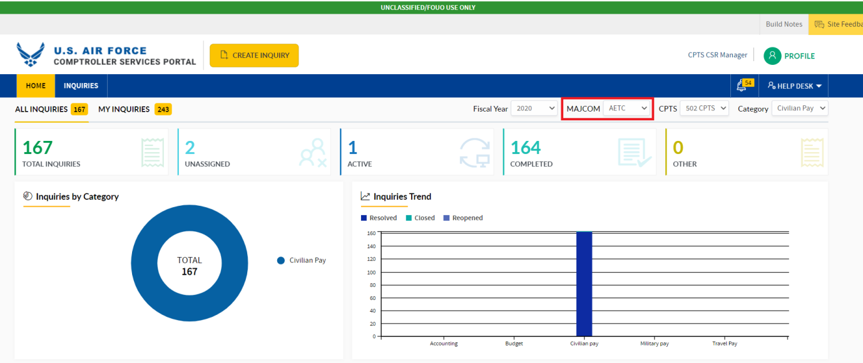

1. **Notification pop up** :   
   a) Click on **Notification icon**, Pop up will be displayed

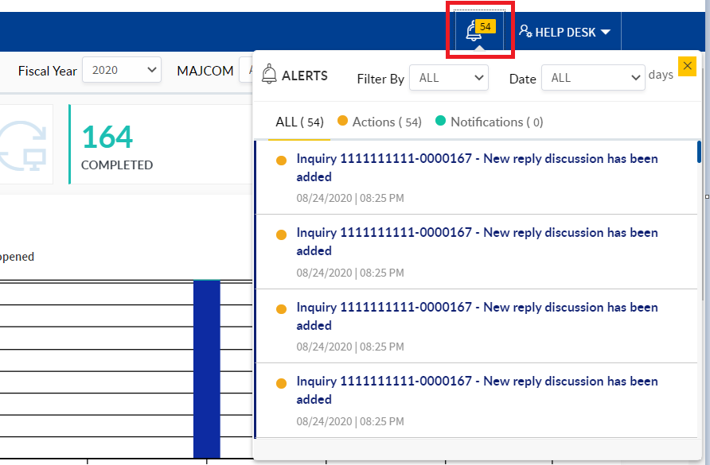

1. Related **Notification and action** will be displayed with date and time.
2. Click on **Action notification**, page will be navigated to **detailed view page**

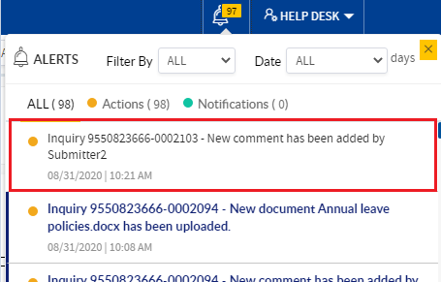

1. Filter by and Date drop down are displayed to filter the **Notifications/Actions**

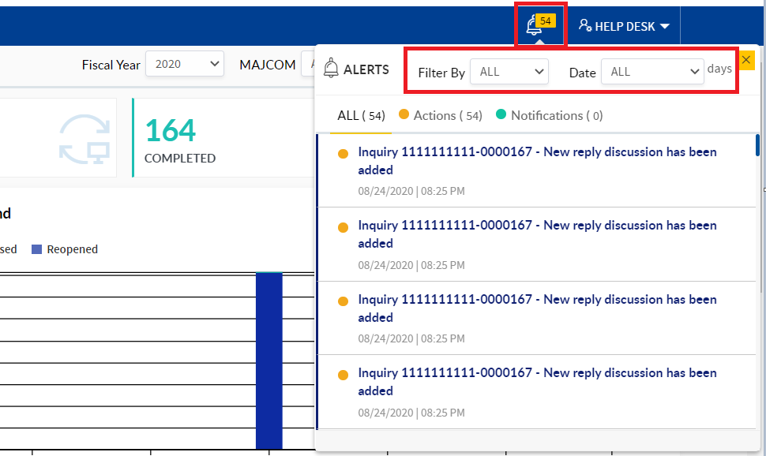

1. Click on **All** heading, **All Notifications and Actions** will display

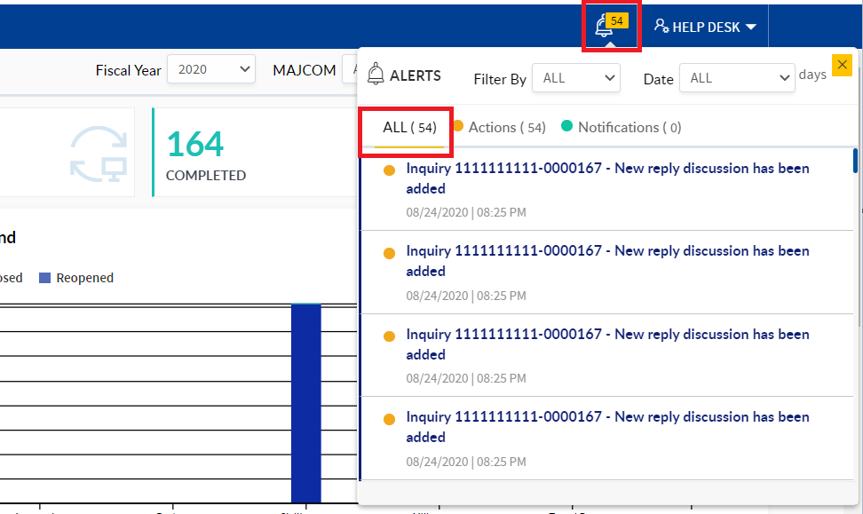

e) Click on Action heading, **All Actions** will display

f) Click on Notification heading, **All Notification** will display

g) Click on Close icon, Pop up will close

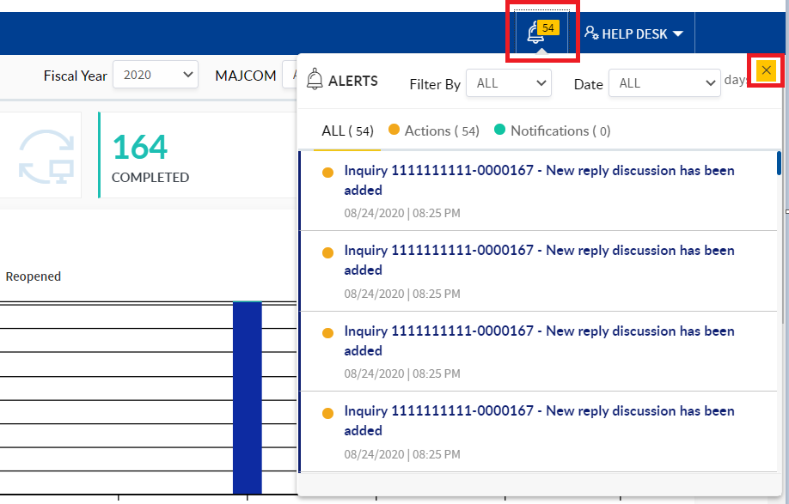

# NAVIGATE TO INQUIRIES PAGE AS CPTS CSR MANAGER

1. In the menu bar, click the **Inquiries tab**

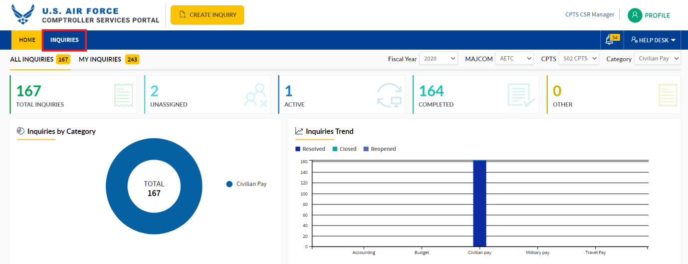

1. Page will navigate to Inquiries home page and in the menu bar Inquiries tab will be highlighted.

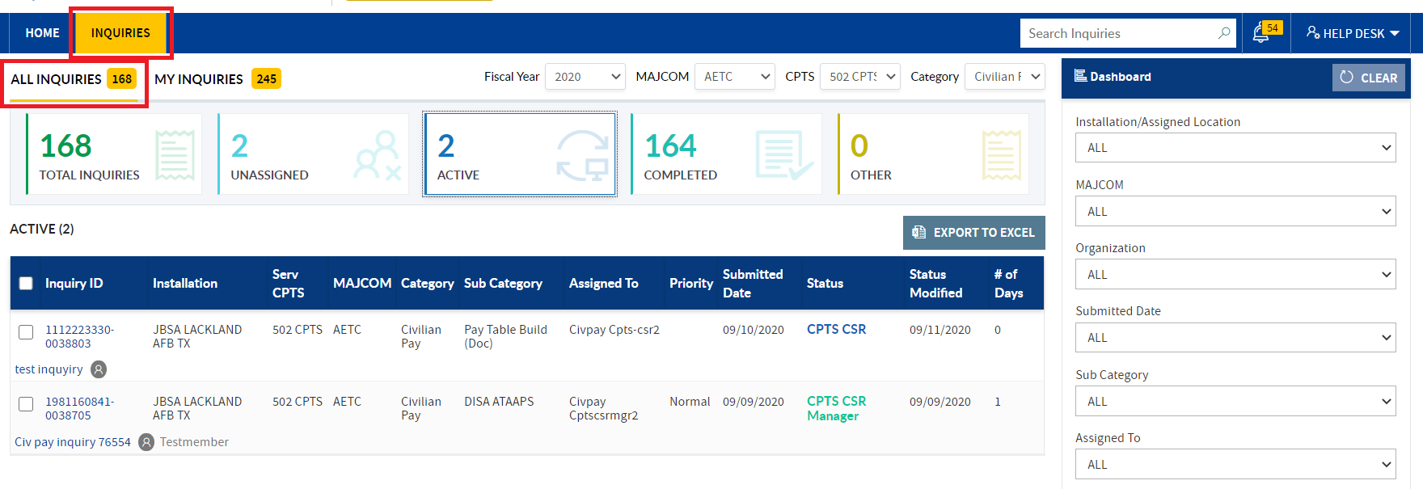

# FEATURES IN INQUIRIES HOME PAGE FOR CPTS CSR MANAGER

Below mentioned features will be visible to CPTS CSR Manager in the Inquiries home page:

1. In the **All inquiries** tab below tiles will be displayed:
   1. **Total inquiries** Tile with **count and related Dashboard** on the right-hand side.
   2. **Unassigned tile** with count and related Dashboard on the right-hand side.
   3. **Active Tile** with count and related Dashboard on the right-hand side.
   4. **Completed tile** with count and related Dashboard on the right-hand side.
   5. **Other tile** with count and related Dashboard on the right-hand side

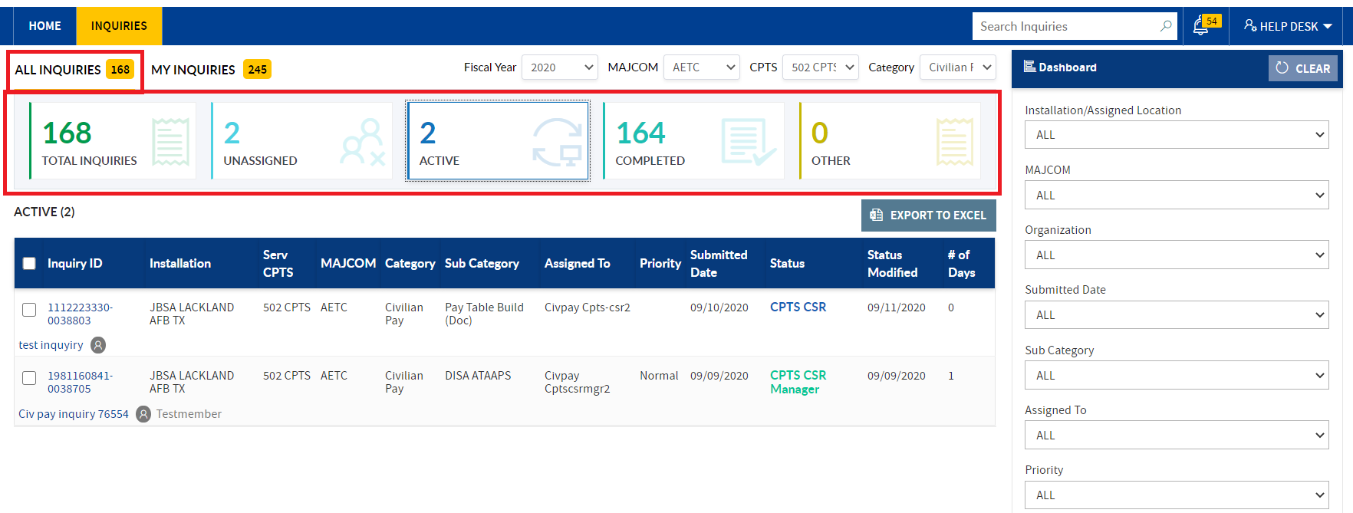

**Note:** By default, Active tile will be highlighted when navigated to Inquiries home page. CPTS CSR Manager Need to work on the Inquiries will be displayed on the top in the respective worklist.

1. **My Inquiries tile** with below tiles will be displayed:
2. **Total Inquiries tile** with count and related Dashboard on the right-hand side
3. **Saved Inquiries tile** with count and related Dashboard on the right-hand side.

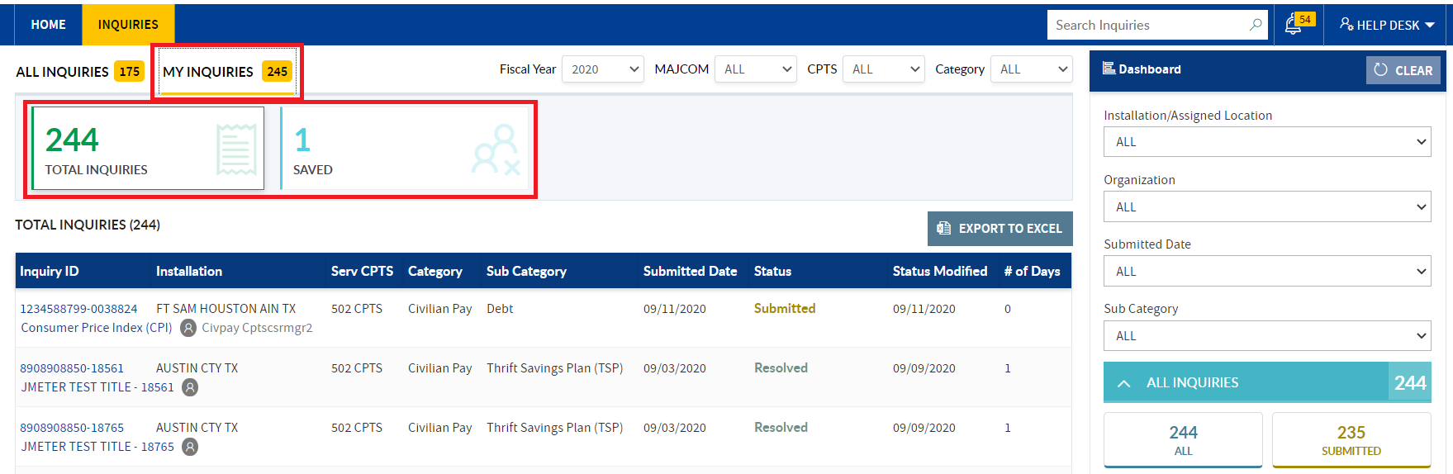

1. **Fiscal Year, MAJCOM, CPTS and Category filters** are displayed above the tiles to filter the inquiries.

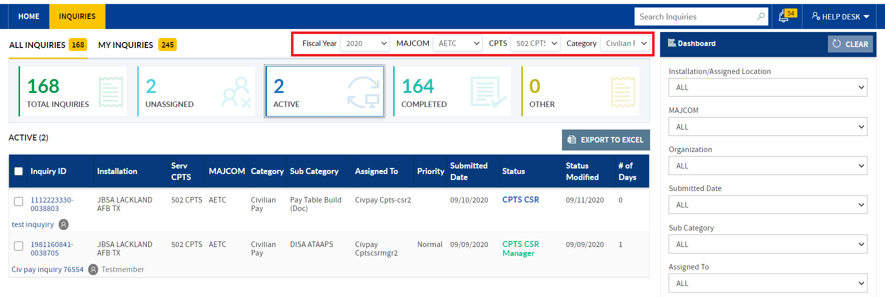

## INQUIRY SEARCH

1) In search textbox enter the **Inquiry ID/Title**, hit on the keyboard enter key/click the search icon

2) Respective inquiry will get filtered in the **All Inquiries tab**.

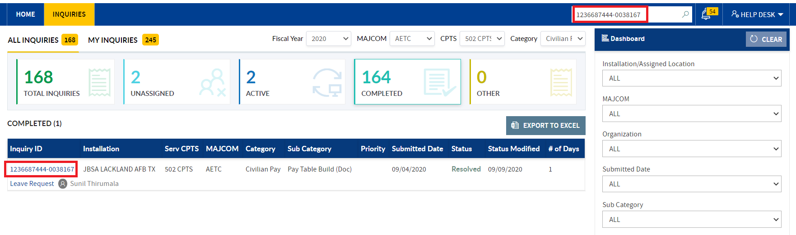

3)To reset the applied search, **clear the entered text in search filed**. All inquiries details will be displayed in the **All inquiries tab** and **dashboard statuses also reset**.

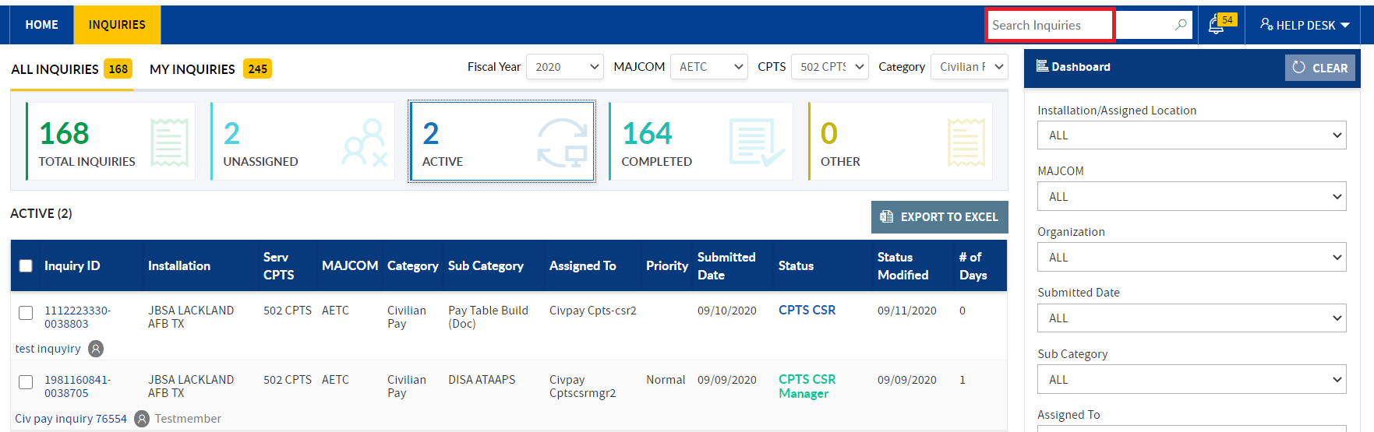

**Note:** To clear the applied search click the clear button provided in the dash board. All inquiries will display in the selected/active tab.

# ALL INQUIRIES TILE

## TOTAL INQUIRIES TILE:

1. In **Total Inquiries tile**, respective CPTS all inquiries will be displayed, irrespective of the status.

**Note:**CPTS CSR Manager, self -submitted inquiries will not be displayed in the respective worklist.

>>**Total Inquiries tile** count = (**Unassigned + Active + Completed+Other**) tiles count.

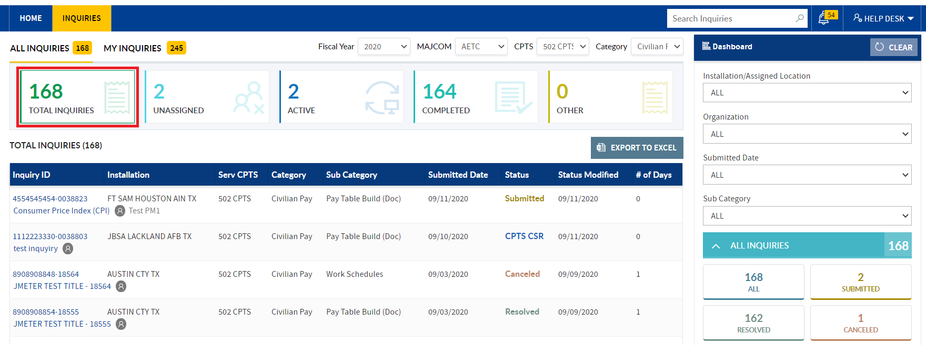

1. Based on the **Fiscal Year, MAJCOM, CPTS and Category**, CPTS CSR Manager can filter inquiries in Total Inquiries tile.

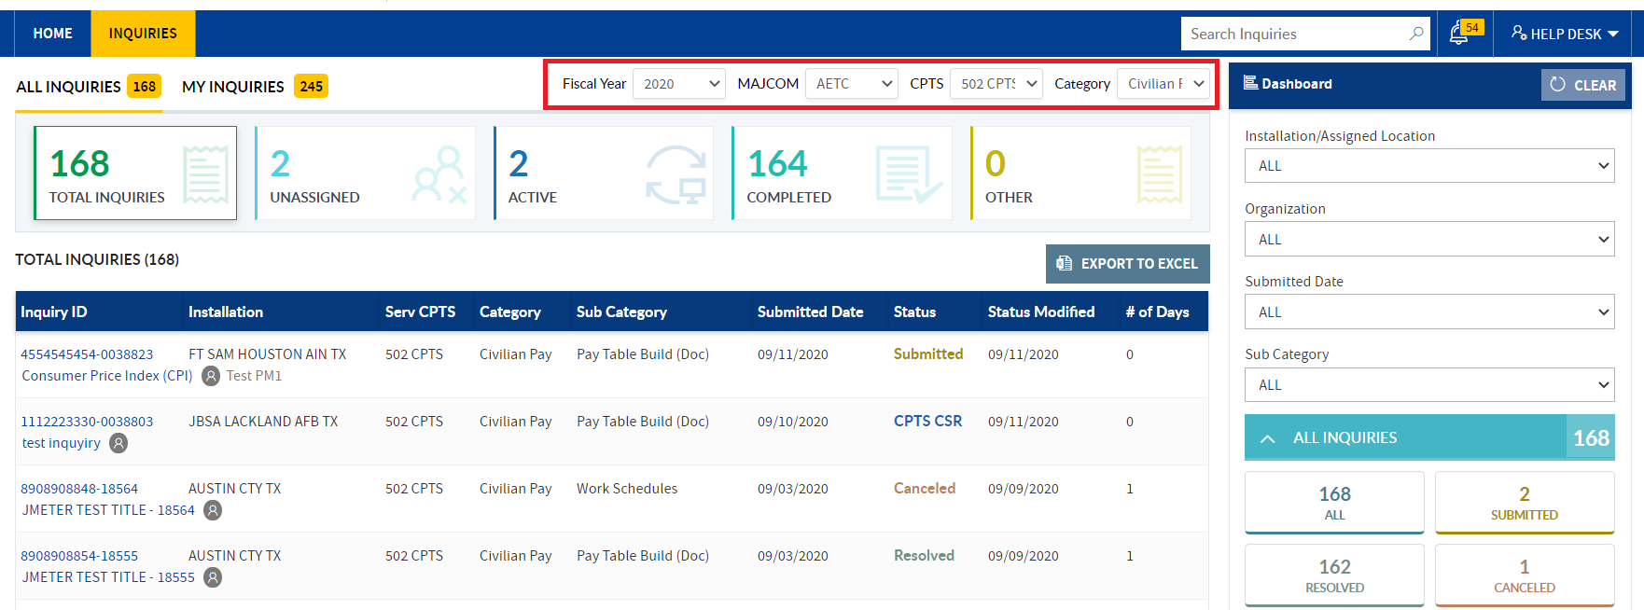

**Note:** Based on the filter selection on the right-hand side Dashboard section, status counts will be change

### DASBOARD SECTION:

**CPTS CSR Manager** can filter inquiries in Total Inquiries tile by applying filters in the Dashboard section:

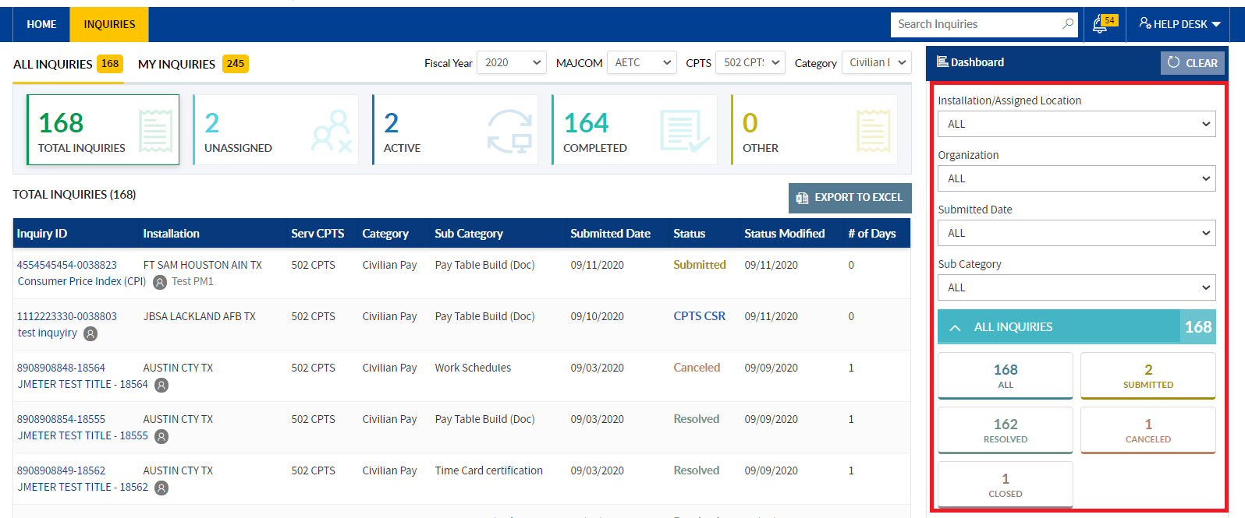

1. Apply the required filters provided in the dash board section to narrow down the filtered inquiries.

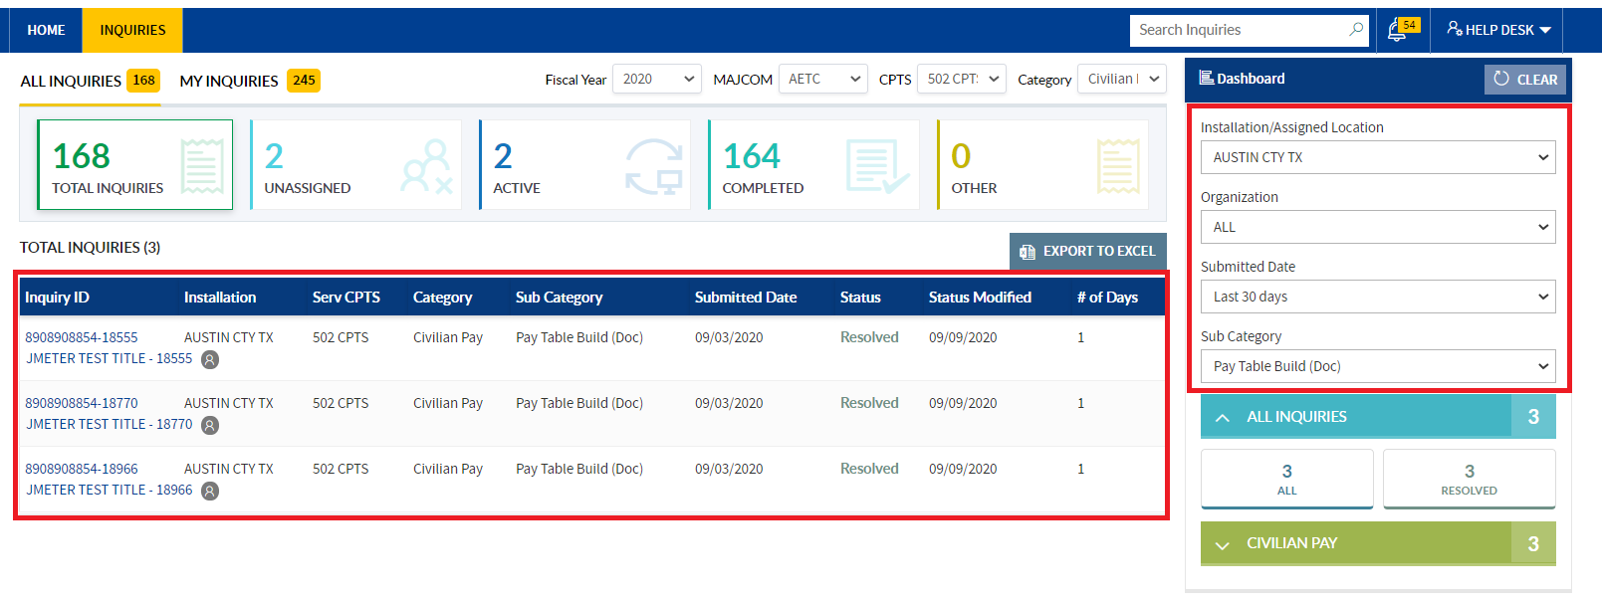

1. Based on applied filters dash board status’s count also changes.

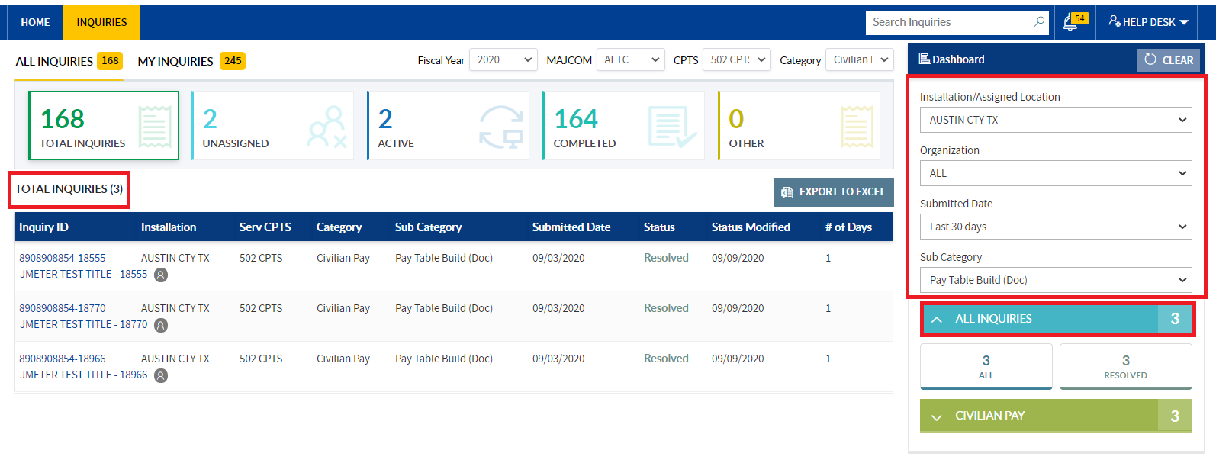

1. To reset the applied filters, click the **Clear button** in the Dashboard section.

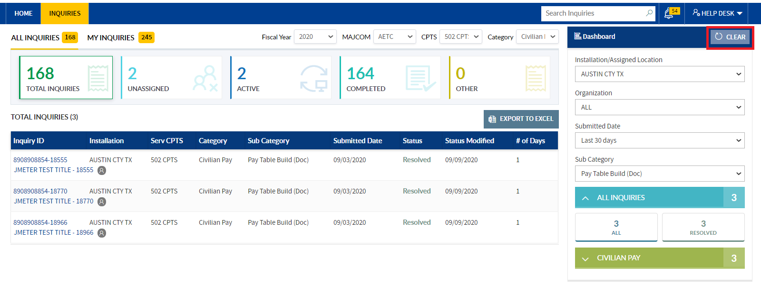

1. Applied filters will be **cleared and All Inquiries** will be displayed in the worklist.

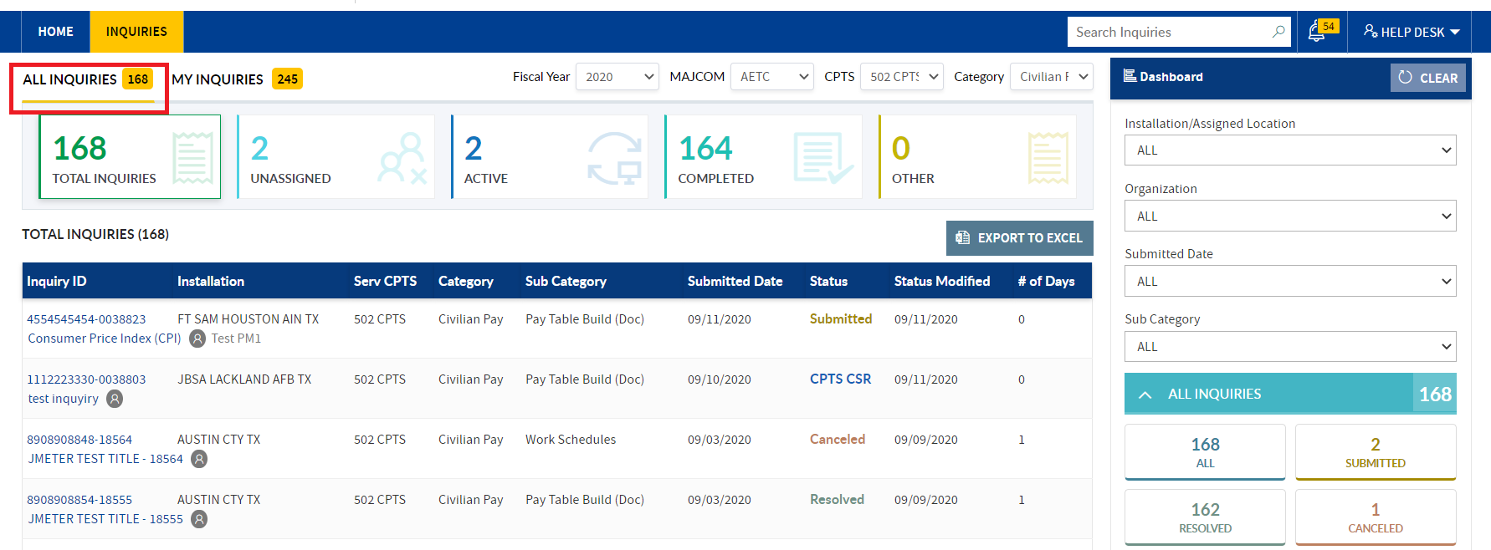

1. **Under Dashboard section**, click the displayed each status, in the Total Inquiries worklist respective status inquiries will be displayed.

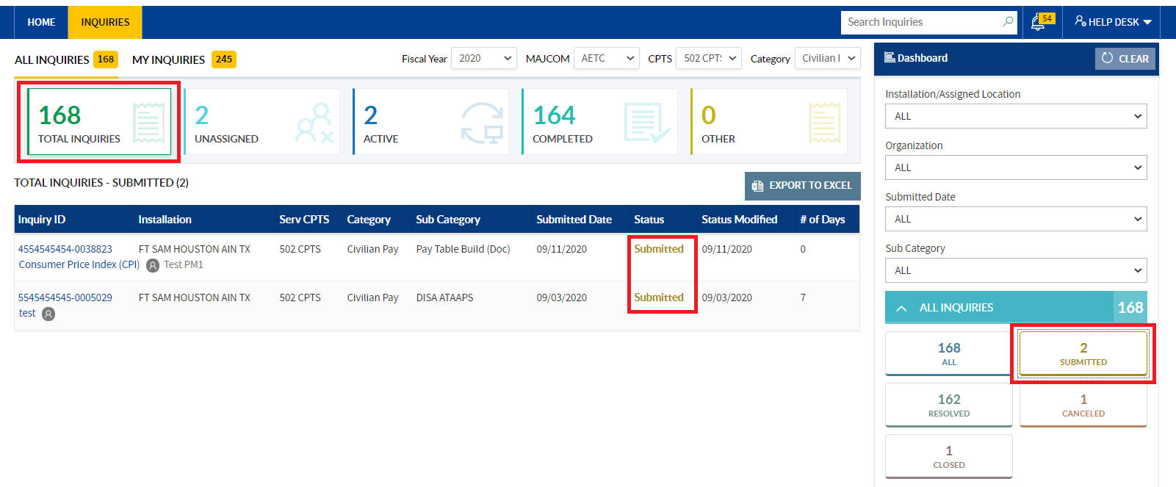

1. By clicking on the Category Status/ “All Inquiries” status, all inquiries will be displayed in the **Total Inquiries tile**.

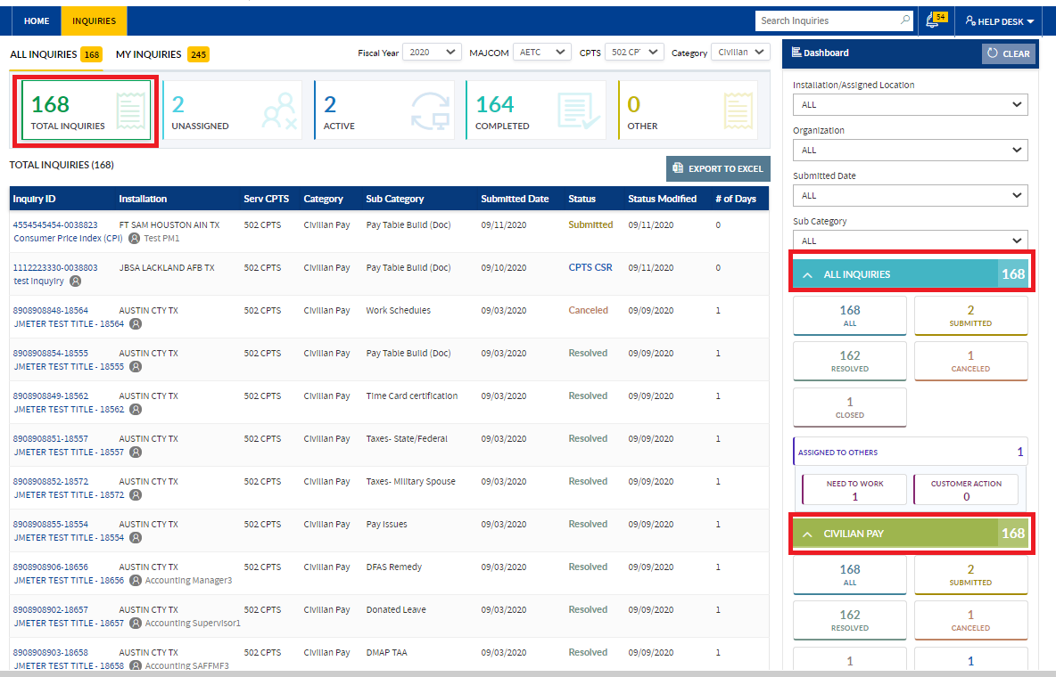

**Note**: Similarly, CPTS CSR Manager can filter respective status inquiries in the **Total Inquiries** tab worklist.

### EXPORT TO EXCEL:

**CPTS CSR Manager** can export total inquiries using **export excel button**.

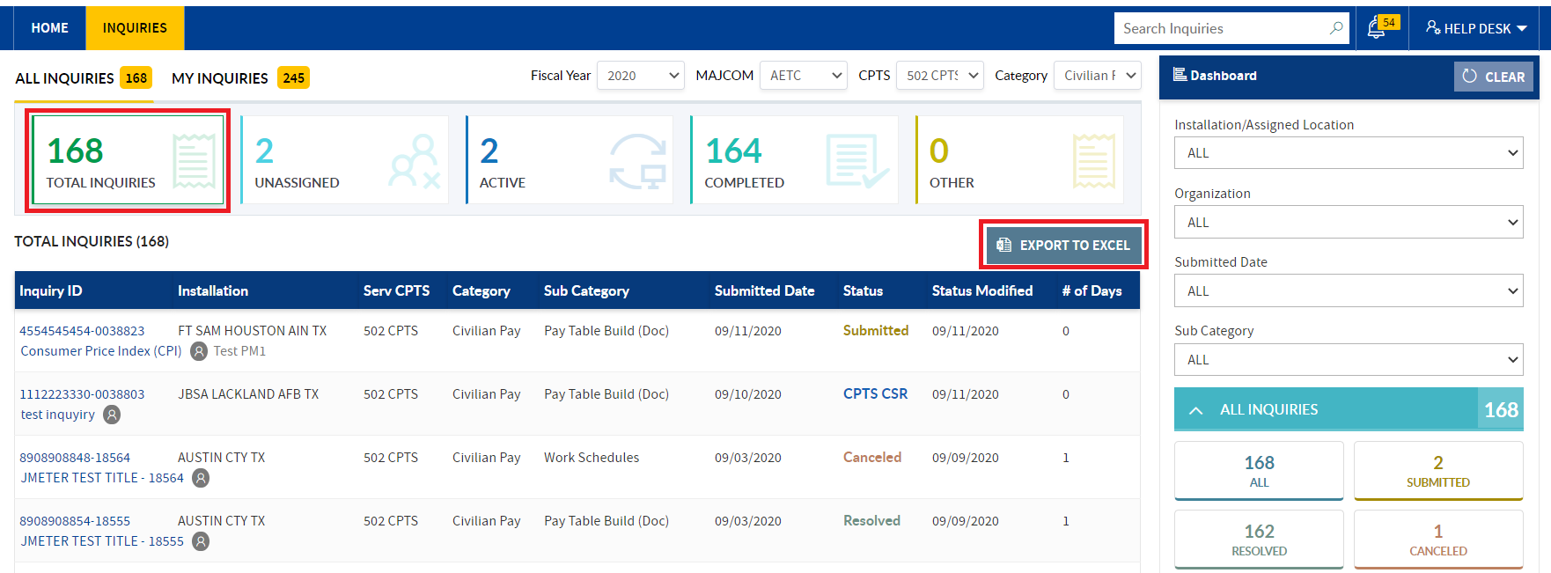

1. Click the Export to Excel button to **export the required** **inquiries**. File will be downloaded into your local system. (based on browser you will get Save or open options also)

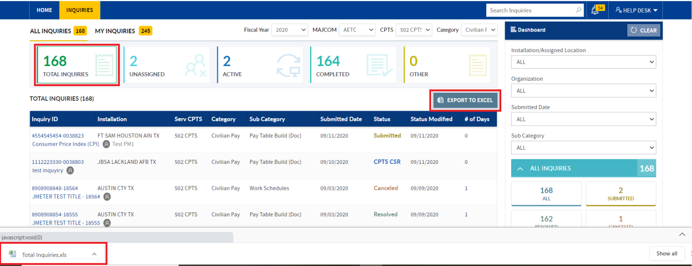

1. To view the requirements details, **open the downloaded excel file**.

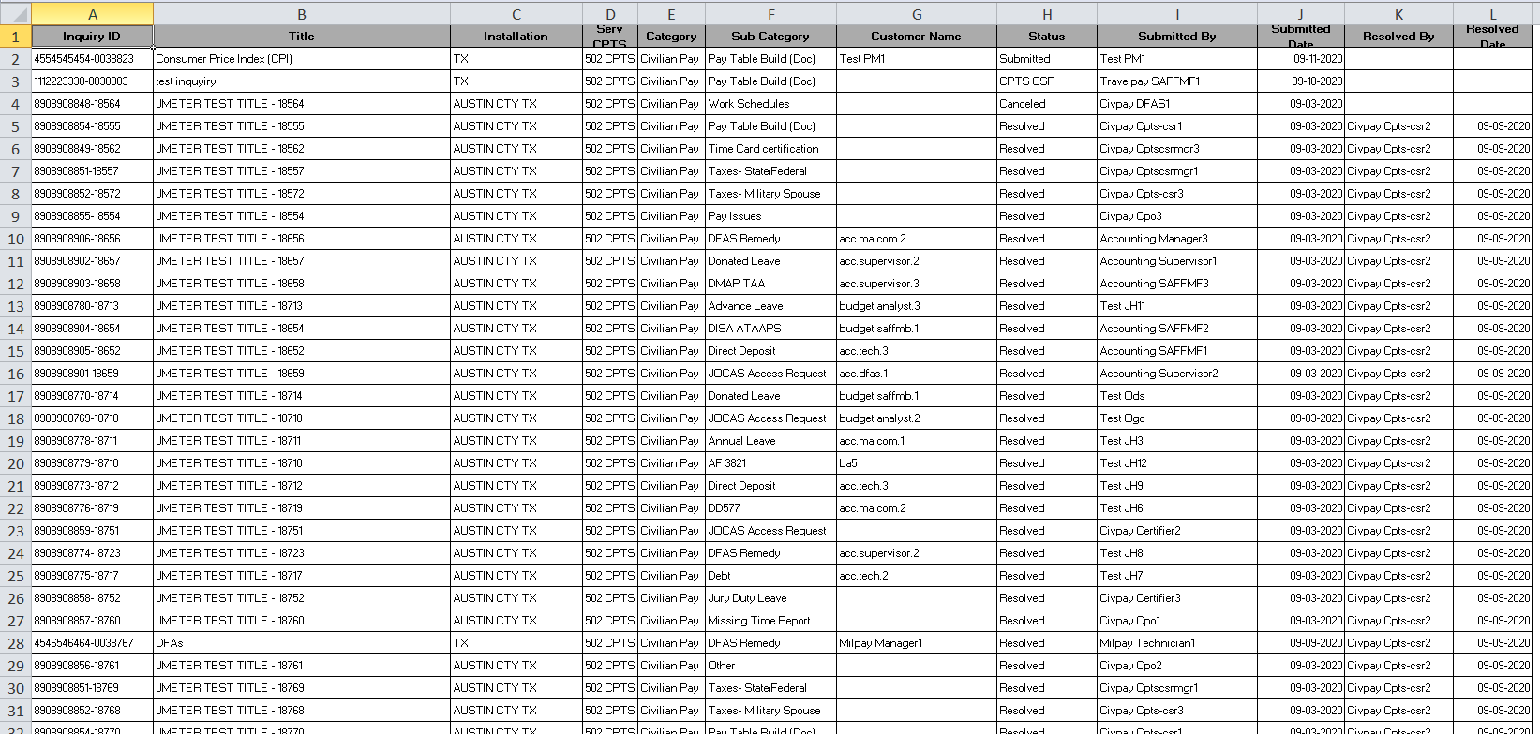

## UNASSIGNED TILE:

1. In the Unassigned tile, **customers submitted /reopened status inquiries** will be displayed.

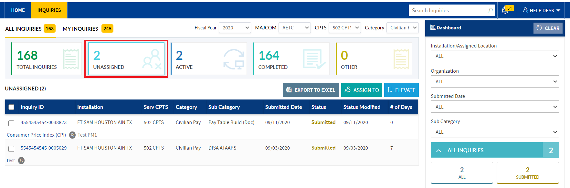

1. From the Unassigned tile, CPTS CSR Manager can perform Export to Excel, **Assign To(Self/other)& Elevate actions.**

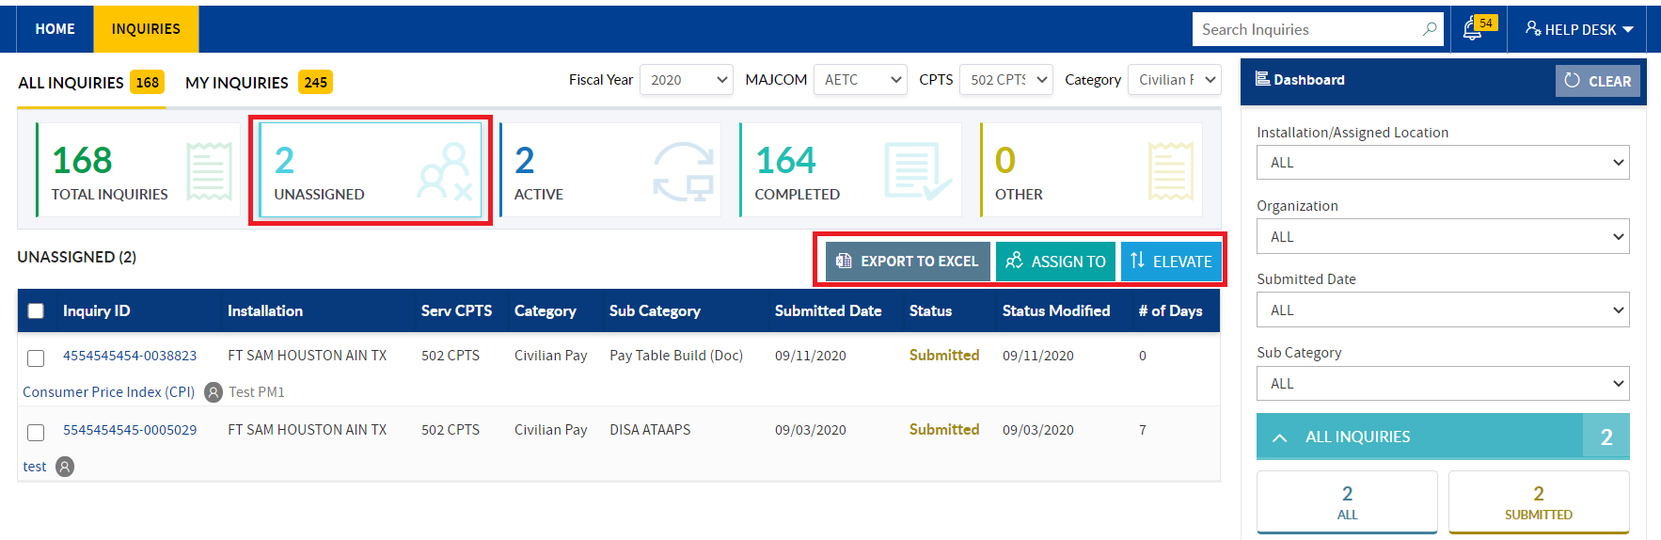

### ASSIGN INQUIRIES BY SELF

CPTS CSR Manager can **self-assign** the inquiries and work on the inquiries to **Resolve**. To Self-assign the inquiry, follow the below steps:

1. In **All Inquiries tab** worklist, click the Unassigned tile
2. In **Unassigned tile**, Choose the inquiry and select the inquiry checkbox

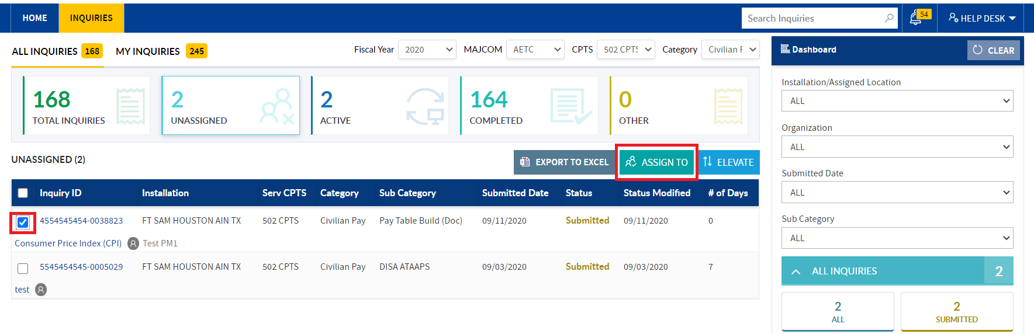

1. Click the **Assign To** button. Popup will be displayed

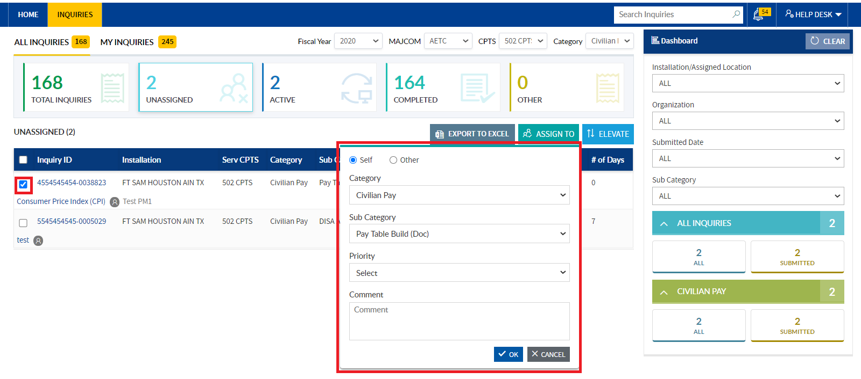

1. By default, "**Self**" radio button will be auto selected & Category and Sub Category field options are auto populated based on the inquiry



1. Select the Priority of the inquiry (Optional) & Enter/copy & paste the comment and click the **ok** button.

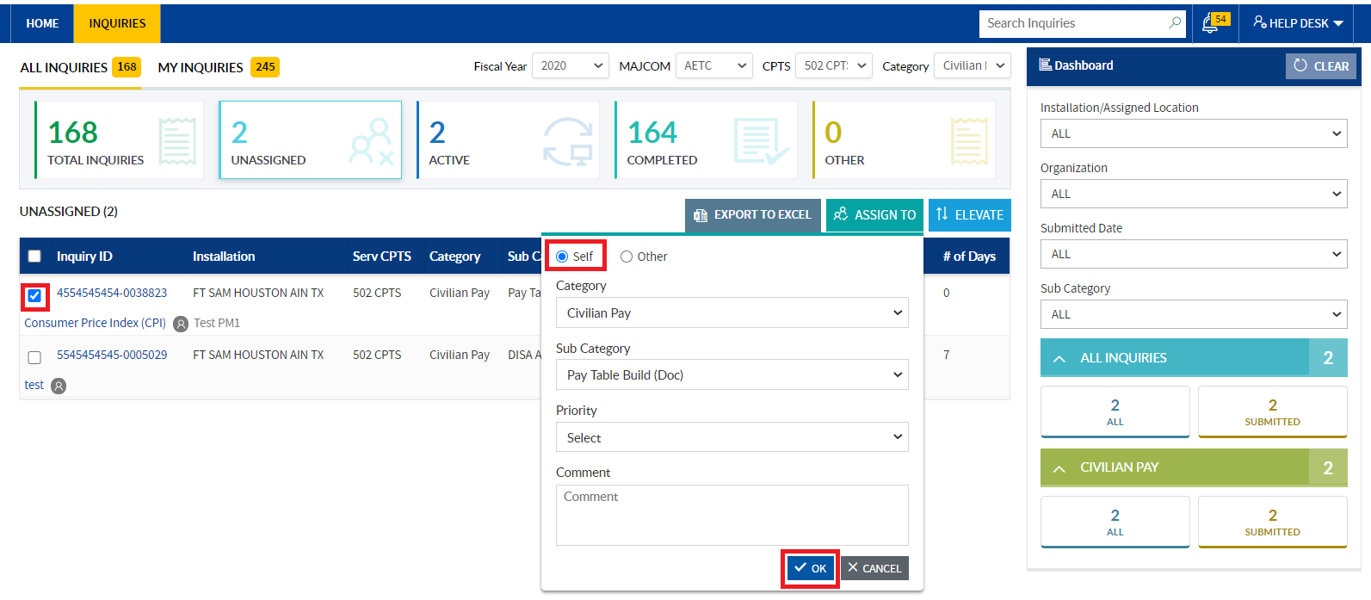

1. In Active Tile respective self-assigned inquiry will be displayed in the worklist with status=”**CPTS CSR Manager**”.
   1. In the worklist under Assigned to column, **self-assigned** user name will be displayed

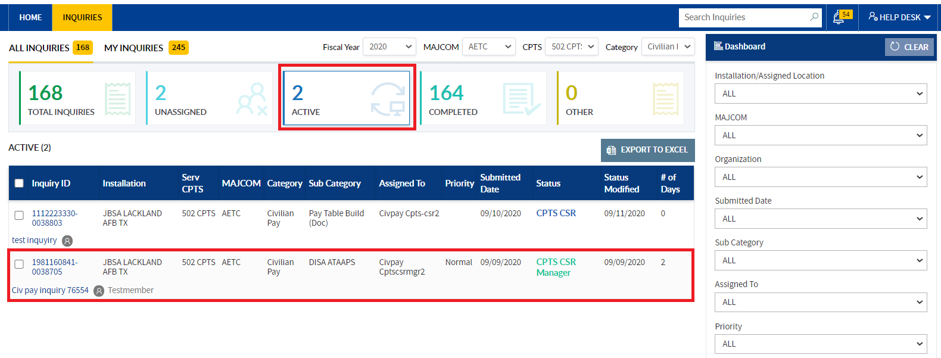

**Note:** Similarly, by following the same steps, **CPTS CSR Manager** can self-assign bulk inquiries.

While assigning the bulk inquiries, in Assign To popup, “Select” will be displayed under the Sub category dropdown

1. Email will deliver for the respective action. And notification will be sent.

### ASSIGN INQUIRIES TO ANOTHER MANAGER

From Unassigned tile worklist, **CPTS CSR Manager** can assign the inquiry to another **CPTS CSR Manager/CPTS CSR**.

1. Select the Inquiry checkbox and click the Assign to button. Popup comes up, select "**Other**" radio button.

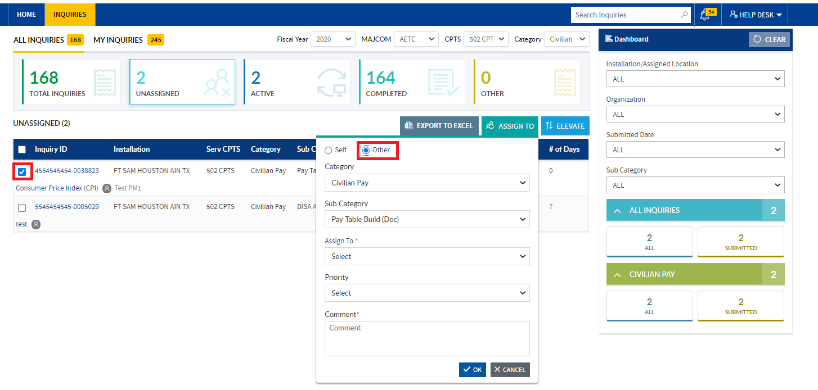

1. In the Assign To dropdown, "**CPTS CSR Manager**" role name will auto populates. Select the Manager name from the sub field dropdown.
   1. **Category and Sub Category options** will auto populate based on the inquiry selection.

**Note:** If bulk inquiries, are selected only Category name will populate.

1. Select the priority for the inquiry & enter the comment and **Click the Ok button**

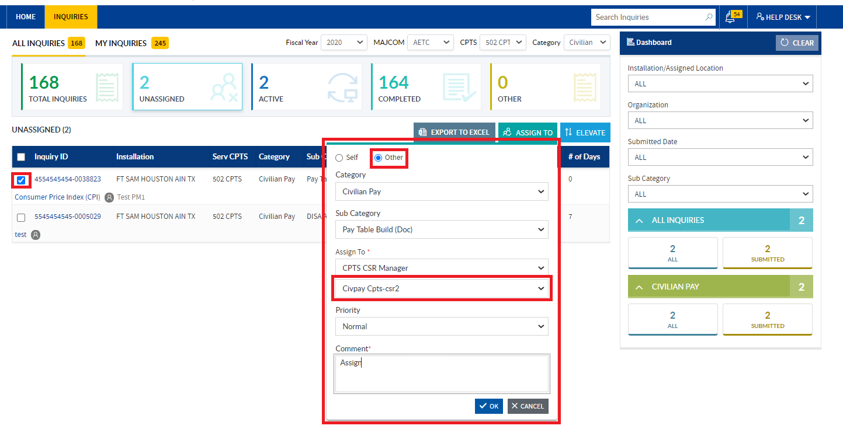

1. Tile will switch to Active tile and Inquiry will be displayed with status =” **CPTS CSR Manager**”. In the worklist, under Assigned to column, **Manager** name will be displayed



1. Email will deliver for respective action.
2. In alert pop up Notification trigger to assigned by user. Action will trigger to **Assign To user**.
3. Similarly, **CPTS CSR Manager** can assign bulk inquiries to another **CPTS CSR Manager**.

### CATEGORY CHANGE:

If inquiry is not related to respective category, **CPTS CSR Manager** has a provision to change the Category from the Assign to popup and assign the inquiry to respective category Manager.

### By selecting the “Self” radio button:

To change the category, follow the below steps:

1. In **Unassigned tile** worklist, select the inquiry checkbox and click the **Assign To** button. Assign to popup will display. By default, “**Self**” radio button will be auto selected.



1. Click the **Category dropdown**, respective **Create Inquiry button** user exists in any another Category, related Category name will be displayed in the dropdown.

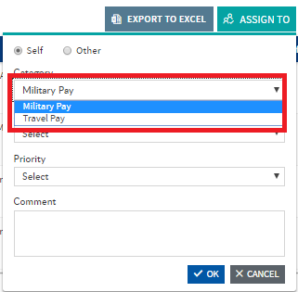

1. Select the **Category name**, based on it in the Sub Category dropdown options will be displayed. Select the Sub category name (Optional)
2. Select the **Priority** from the dropdown (Optional) & enter the comment and Click the **Ok** button

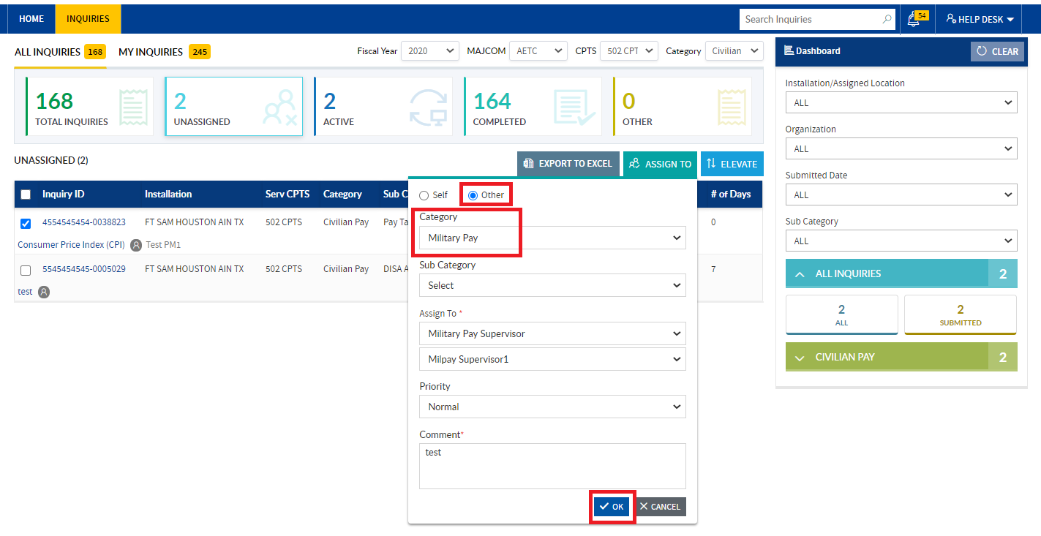

1. Inquiry should not be displayed in the **Unassigned Tile** worklist.
2. To verify the assigned inquiry, in the **Category dropdown select the respective changed category name** from dropdown and view the **Active Tile** worklist.

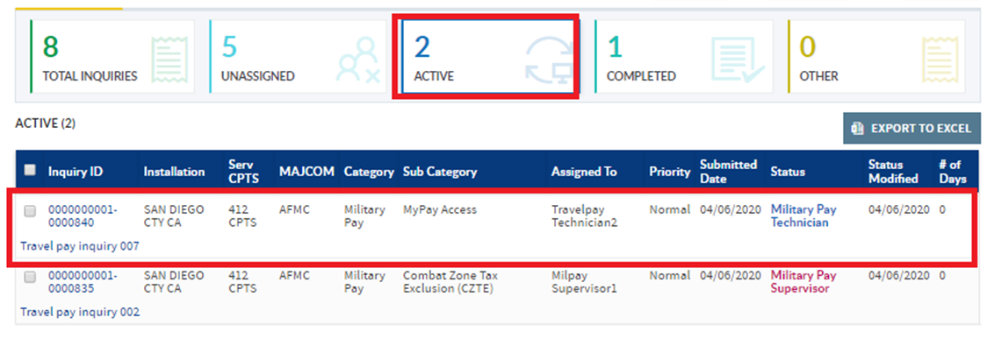

1. In the **Active Tile** worklist respective category changed inquiry should be displayed.

### By Selecting the “Other” radio button:

1. Unassigned Tile worklist select the inquiry checkbox and then click the **Assign to** button.



1. Popup will be displayed. Select the **“Other”** radio button.



1. In the **Category dropdown**, change the category name. Based on the Category selection, sub category options will be filtered. Select the Sub Category name (Optional)
2. Select the **Priority** from dropdown (Optional) & enter comment and Click the **Ok** button.



1. Tile will switch to Active tile. But inquiry should not be visible to **CPTS CSR Manager**.

**Note:** If **CPTS CSR Manager** user exists in the respective selected category then inquiry will be visible.

### ELEVATE INQUIRIES TO CPO/AFIMSC

From Unassigned Tile CPTS CSR Manager can directly elevate the inquiry to CPO/ AFIMSC Information.

1. In All Inquiries tab worklist, click the **Unassigned Tile**.
2. In the worklist, choose the inquiry and select the inquiry checkbox and click the **Elevate button.**

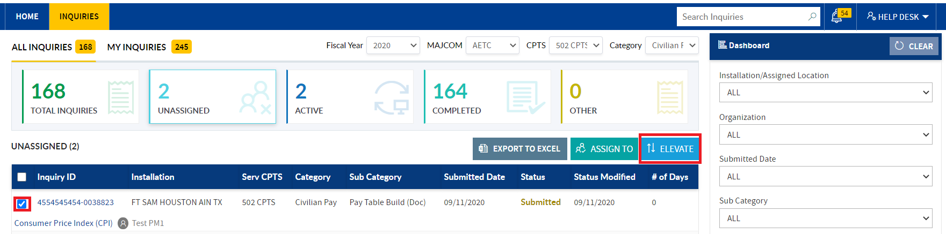

1. **Elevate popup** will display.

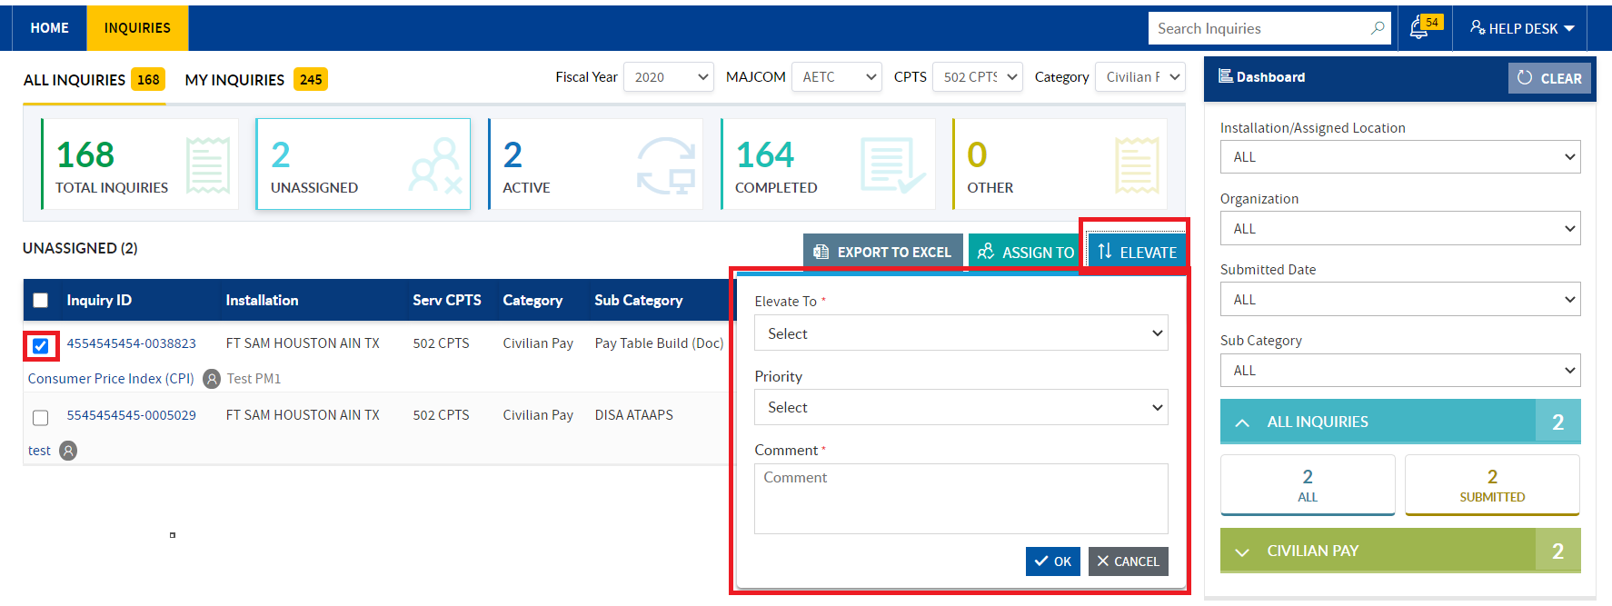

1. In **Elevate To** dropdown select the role where you need to elevate.

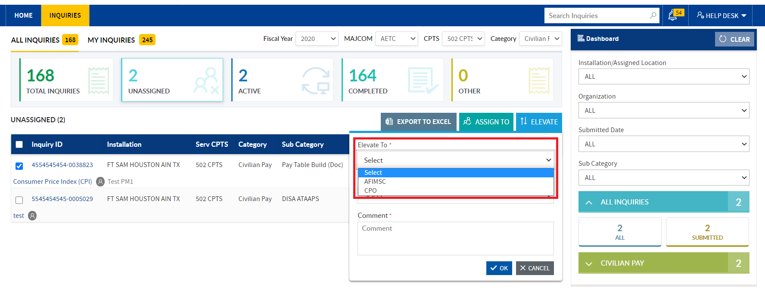

1. Select the priority from the dropdown (Optional) & enter/copy & paste the comment. And Click the **Ok** button.

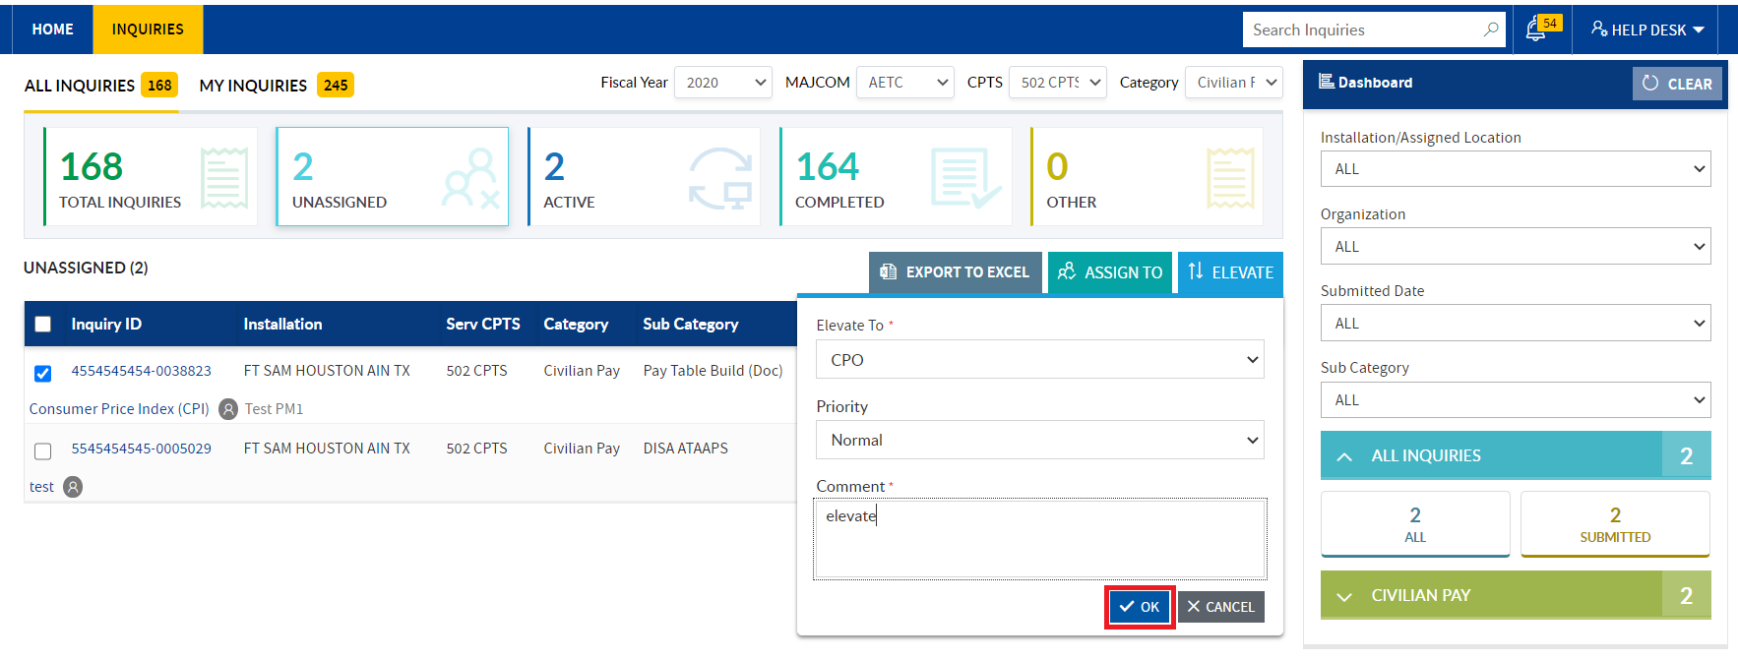

1. Tile will be switched to Active Tile and **inquiry of the status** will change based on the role Elevate. In the Dashboard section, respective status count will increment.

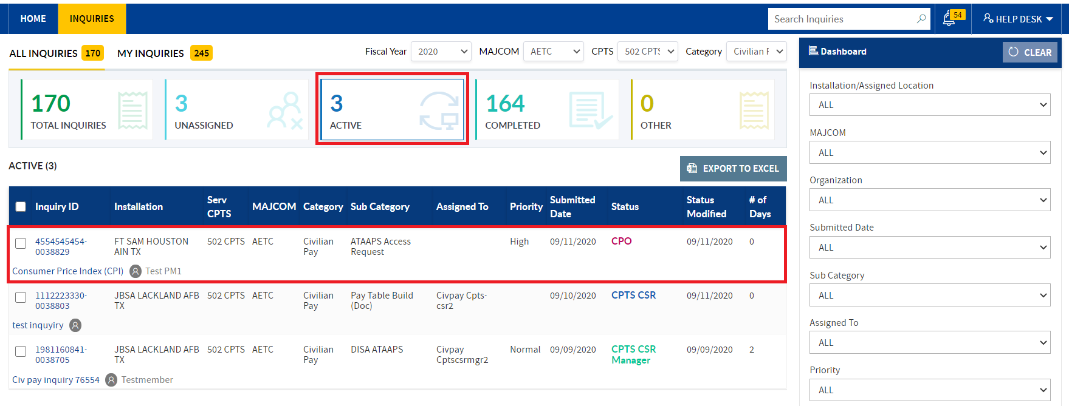

Similarly, CPTS CSR Manager can elevate the multiple inquiries at a time.

1. Email will deliver for respective action.
2. Notification will trigger to CPTS CSR Manager.

## INQUIRIES IN ACTIVE TILE:

Inquiries need to work by CPTS CSR Manager/assigned to Other Managers /Assigned to CPTS CSR &elevated inquiries will displayed in the Active tile worklist.

In the Active tile, CPTS CSR Manager can filter inquiries based on the **Fiscal Year, MAJCOM, CPTS and Category.**

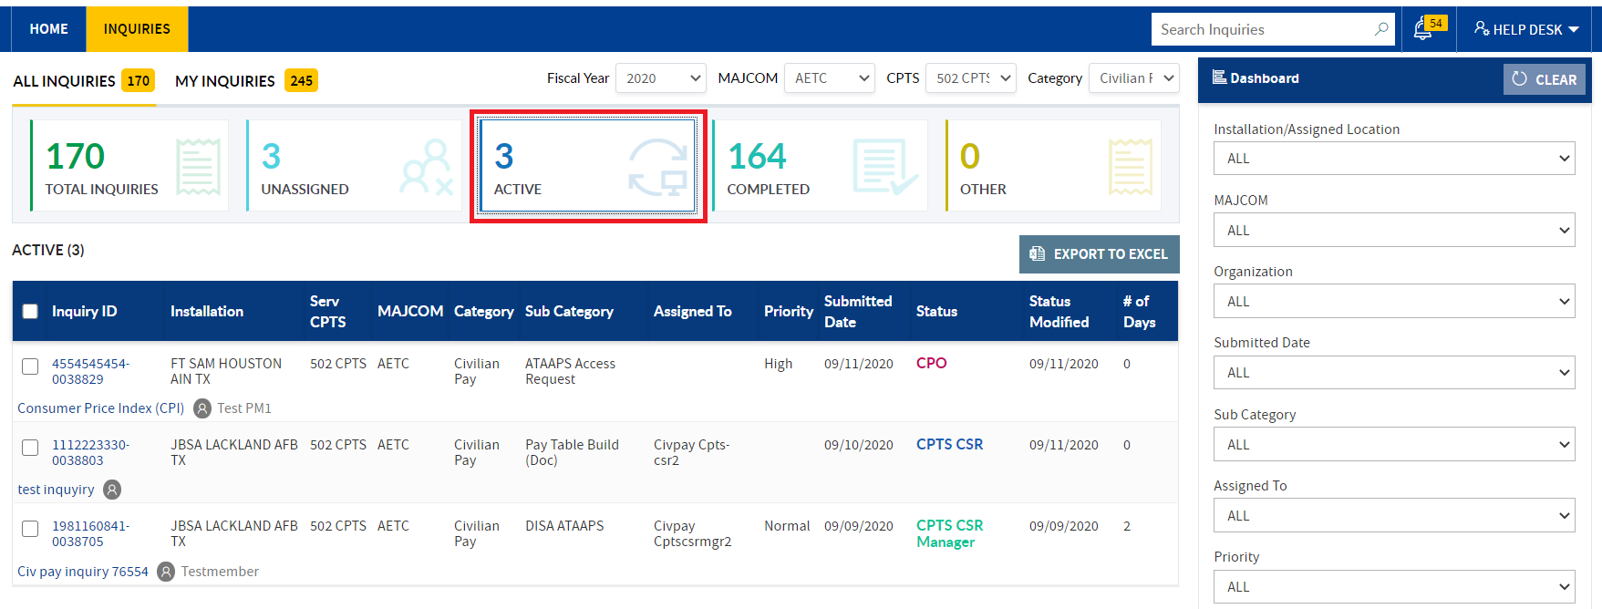

In the **Active tile work**list, based on the status click, action buttons (**Assign to and Elevate**) will be displayed

### CLICK THE ASSIGN TO ME status:

1. When navigated to Inquiries home page, **Active tile** worklist is displayed by default.
2. In the Dashboard section, click the **Assigned to Me** status

In the Active tile worklist, inquiries which are self -assigned/assigned to respective CPTS CSR Manager will be displayed with Assign to and Elevate buttons

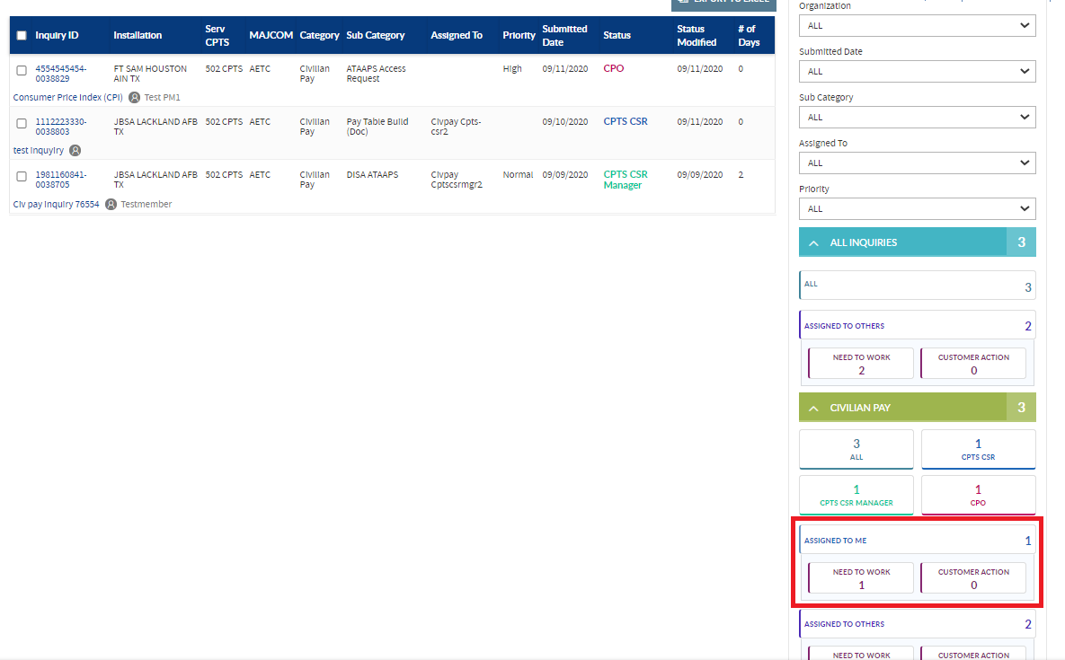

### ASSIGN INQUIRY TO ANOTHER CPTS CSR MANAGER

1. Select the inquiry checkbox, click the **Assign to** button

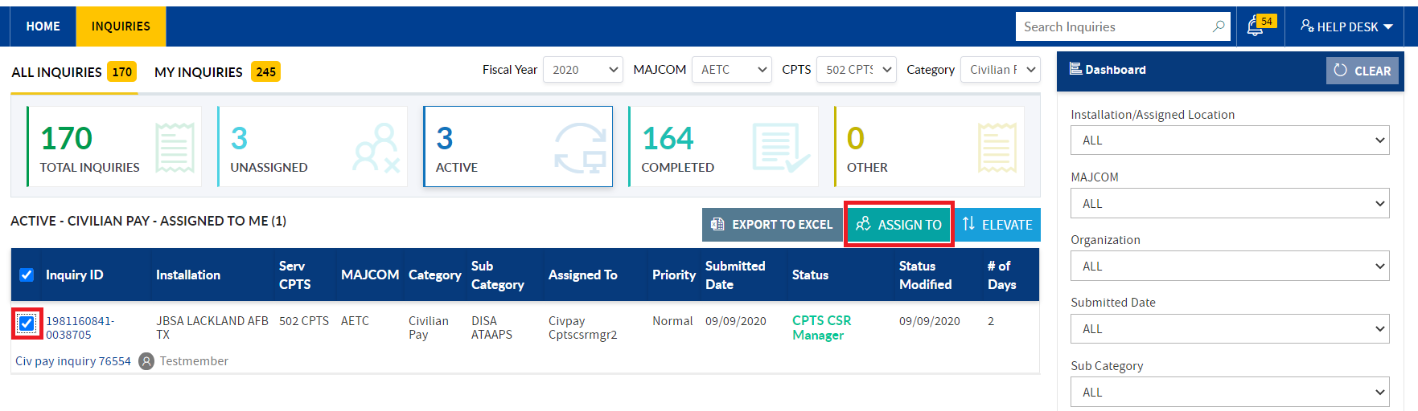

1. Assign To popup will display. Select the **Manager/ CPTS CSR name** from the field.

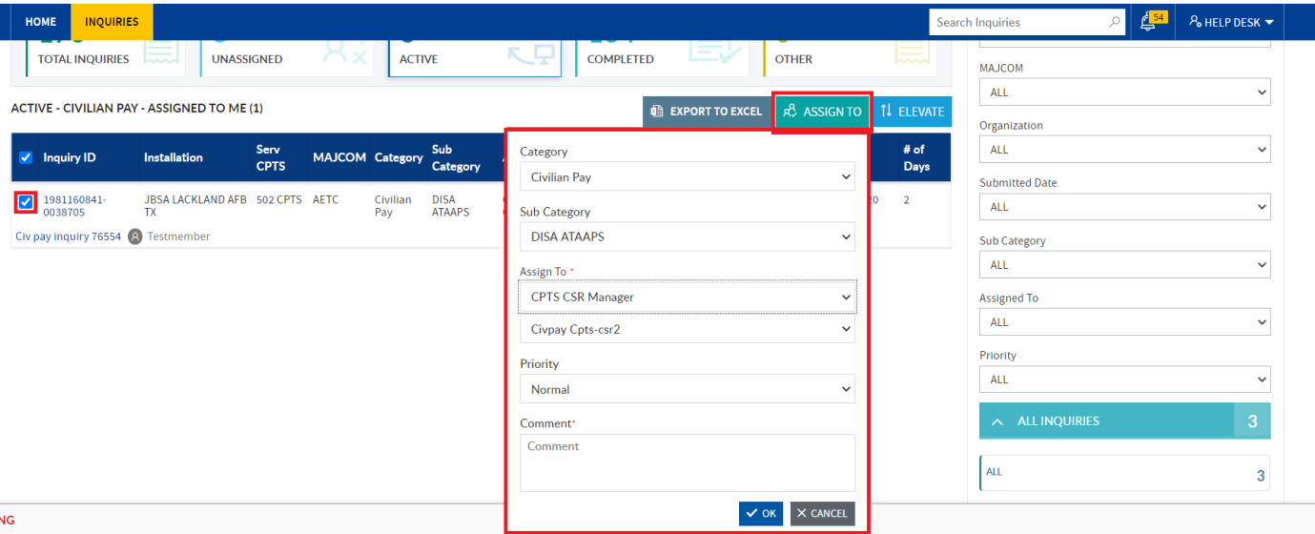

1. In **Assign To** dropdown role will auto populate, select the **Manager** name from the sub field dropdown. Category and Sub Category fields dropdown options will auto populate
2. Select/update the Priority option & enter/copy & paste the comment and click the ok button.

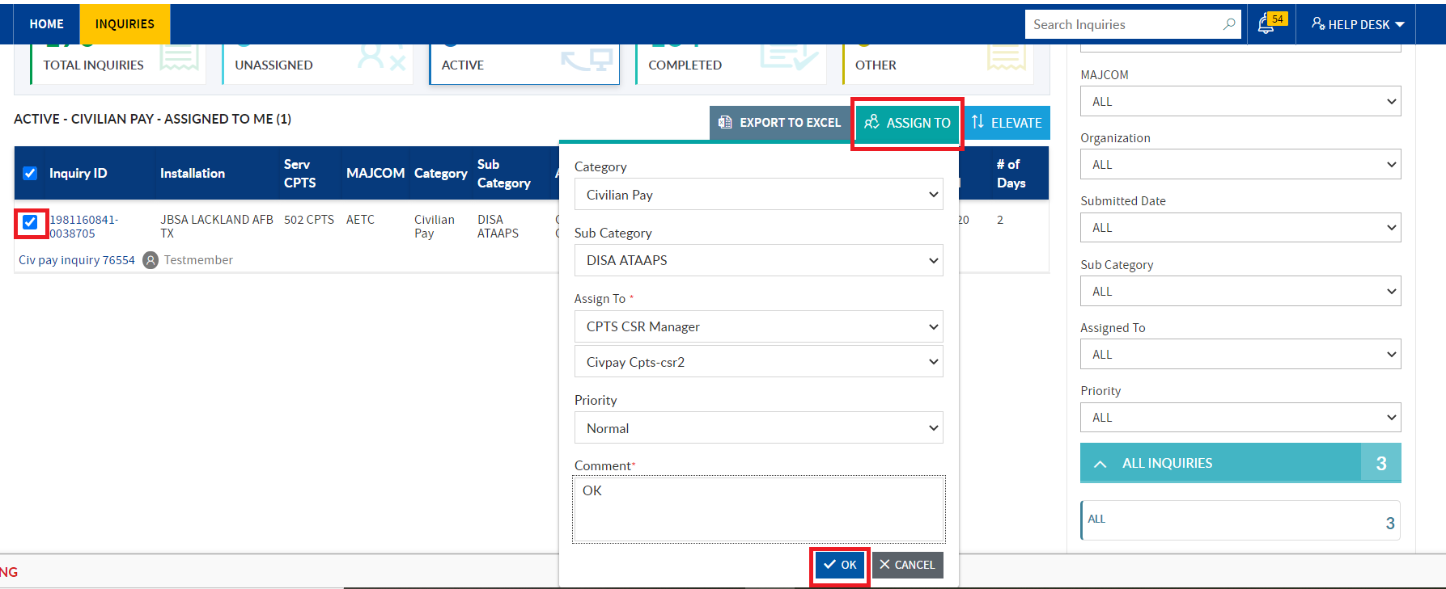

**Note:** When bulk inquiries are selected, under Sub category dropdown default “**Select**” option will be displayed

1. Respective inquiry will be assigned to other Manager and in Assigned to Others status count should be increment. In **Assign To Others status click respective inquiry will be filtered**.

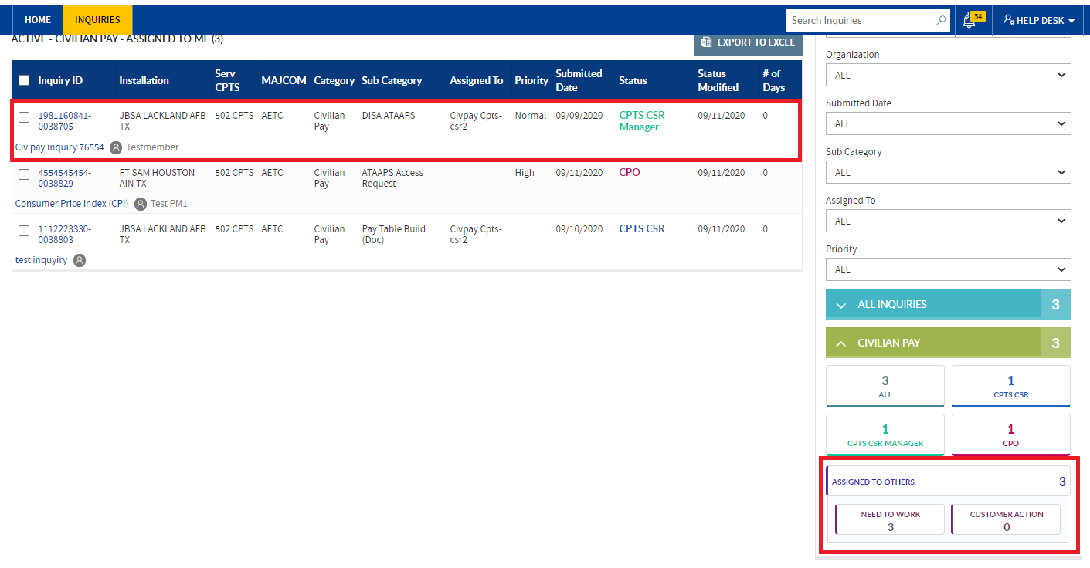

Similarly, **CPTS CSR Manager can assign bulk inquiries to another CPTS CSR Manager/Other CPTS CSR**.

1. Email will deliver for respective action. and notification will be trigger for respective action.

**Note:** In Assign to popup **CPTS CSR Manager** can change the **Category and assigned to respective category Manager**. (Please refer to Category change steps mentioned in the Unassigned Tile).

### ELEVATE INQUIRY TO CPO/AFIMSC

1. In the **Active tile** worklist, Dashboard section clicks on the Assigned to Me status.

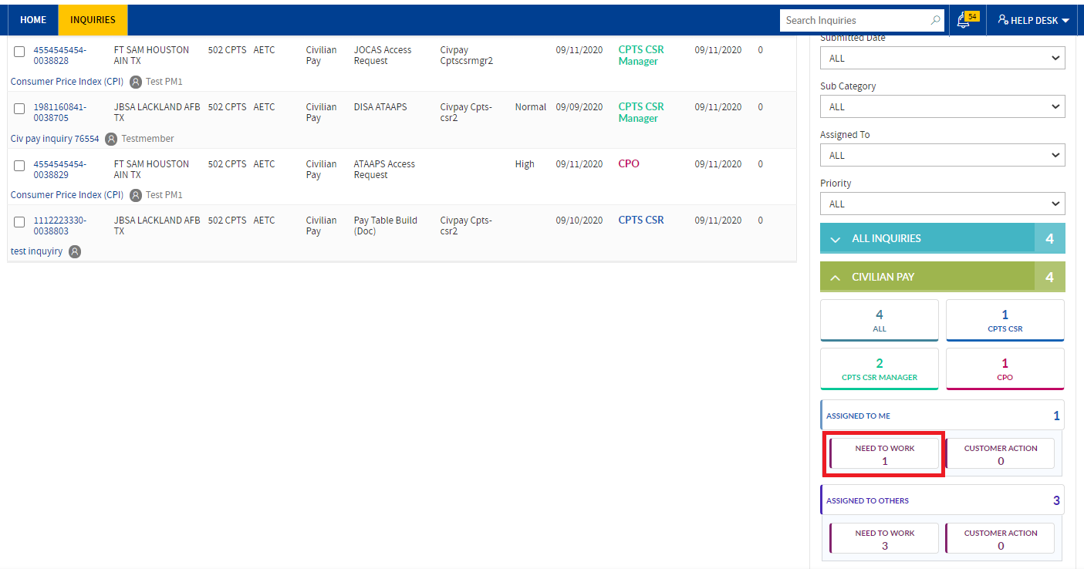

1. In the Active tile worklist, **Assign To and Elevate action buttons** will be visible.

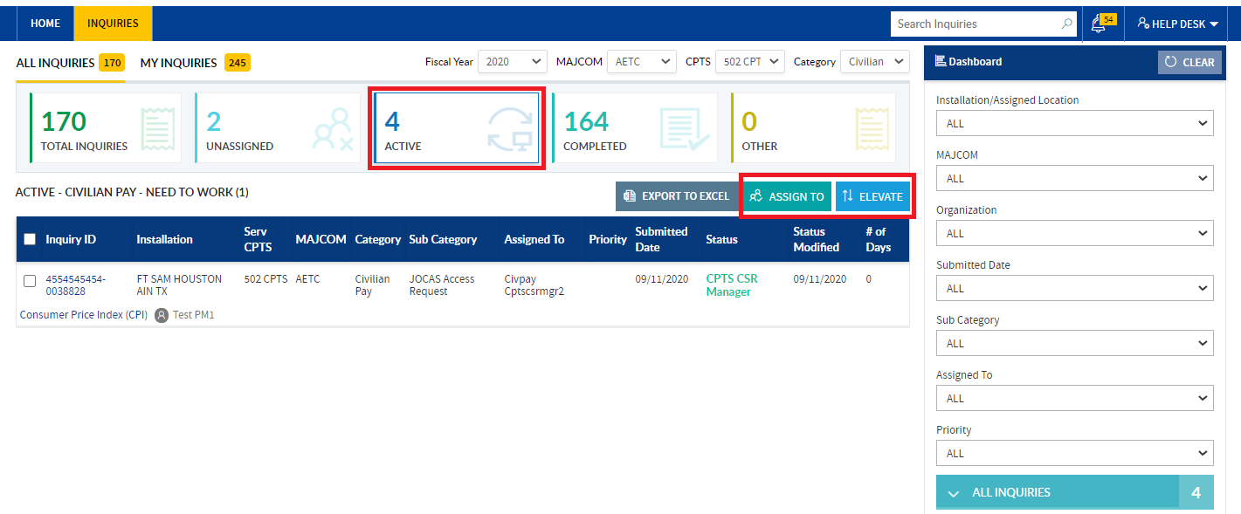

1. Select the inquiry checkbox and click the **Elevate button**.

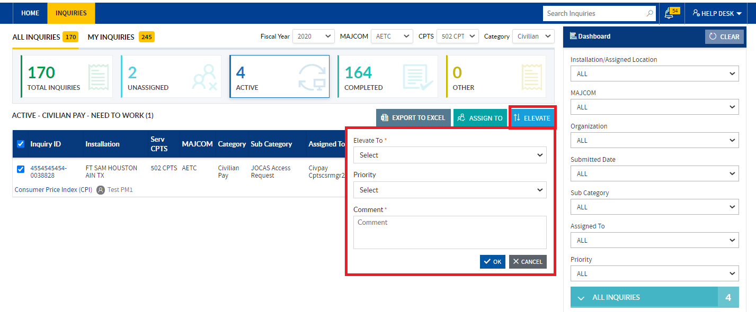

1. Elevate to popup will displayed, in the **Elevate to dropdown** select the role need to elevate

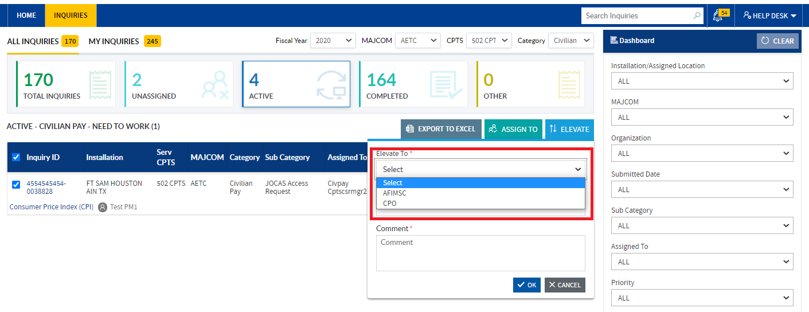

1. Enter/copy paste the comment and click the **Ok button**

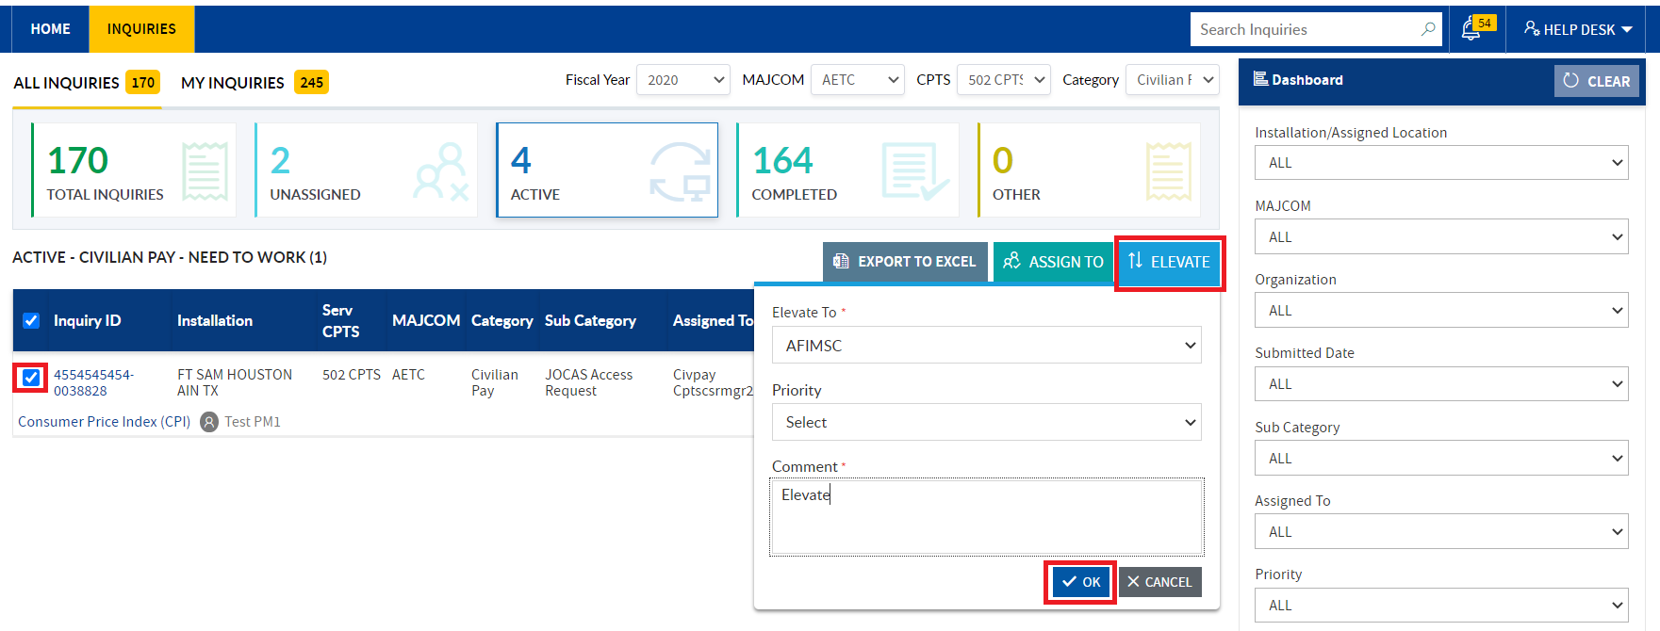

1. Inquiry status will be changed based on the role elevation and in the **Dashboard section**, respective status count will increment

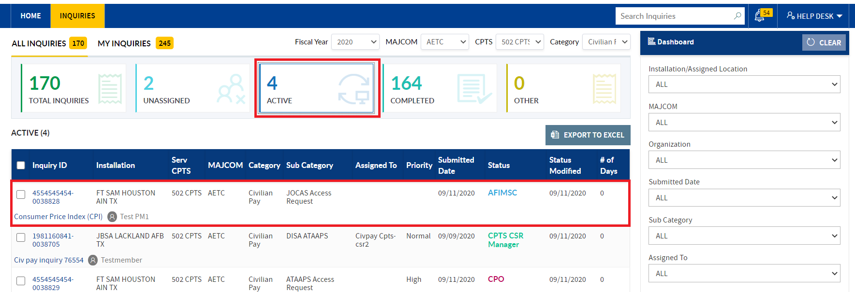

Similarly, **CPTS CSR Manager can elevate the bulk inquiries.**

1. Email will deliver for respective action. And notification will be triggered.

### DASHBOARD SECTION (when ACTIVE Tile is in Active)

1. If **CPTS CSR Manager** under Dashboard section clicks the **CPTS CSR Manager status**, Assign to and Elevate action buttons **should not be visible**.
   1. **CPTS CSR Manager** can view the details in the worklist

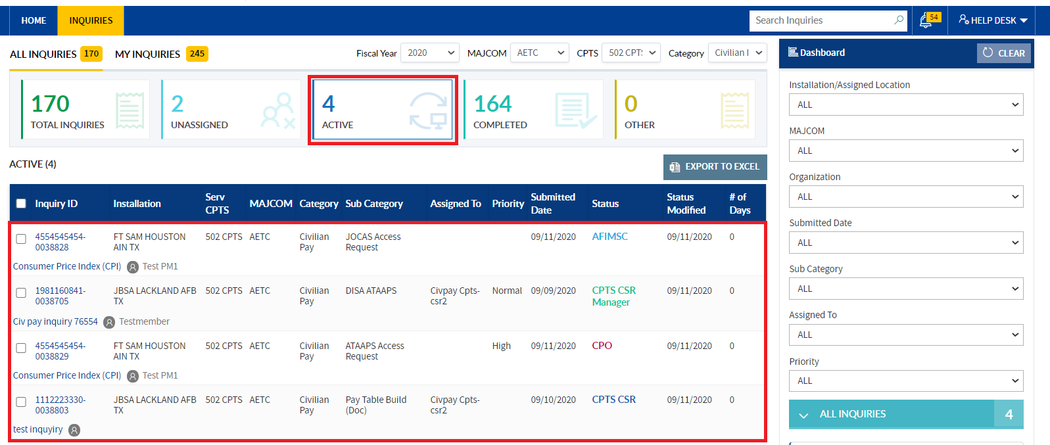  
Similarly, when clicked on the **CPO/AFIMSC/SAF FMF** status’s no action buttons will not visible.

1. To filter the required inquiries apply the filters provided in the dash board section.

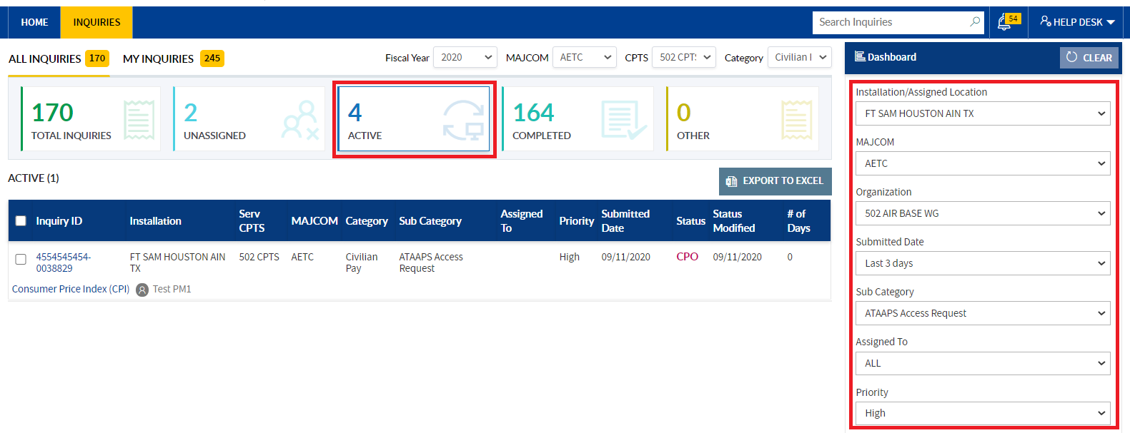

1. To reset the applied filters, click the **Clear button**

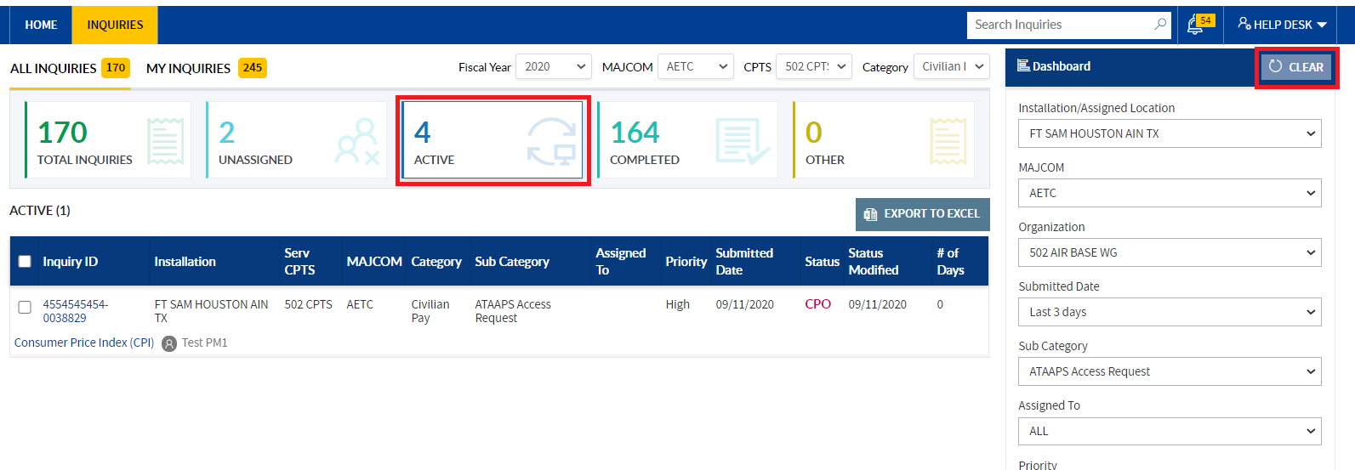

## COMPLETED TILE:

1. In All Inquiries tab worklist, click the **Completed Tile**

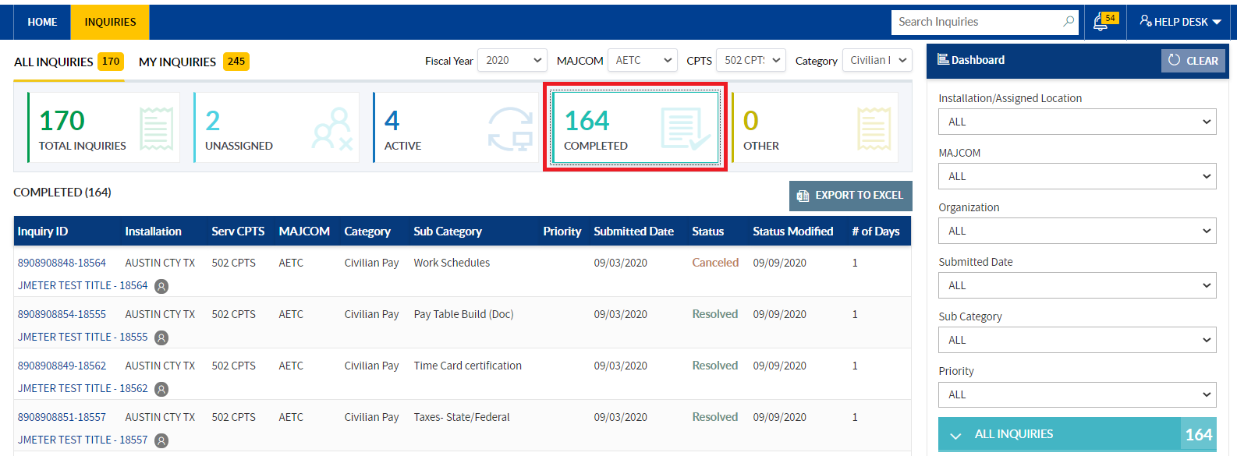

1. Inquiries status=**”Resolved”/” Closed”/”Canceled”** inquiries will be displayed in the respective tile worklist.



**Note:** For Dashboard actions please refer to **UNASSIGNED TILE –DASHBOARD SECTION** steps.

## OTHERTILE:

1. In all inquiries tab click the other tile.

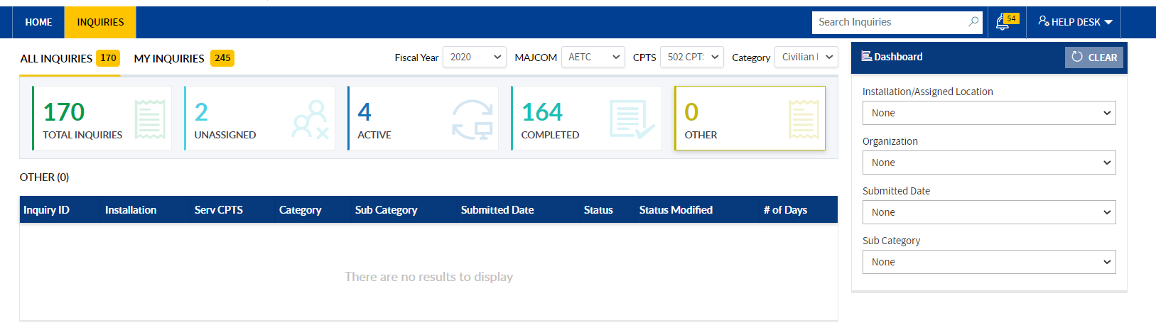

1. Inquires submitted to other user for other categories & added as team member to other (**Travel pay/Military pay**) category inquires will display in other tile.

# MY INQUIRIES TAB WORKLIST

In **My Inquiries tab** worklist, below tiles will be displayed with count:

1. **Total Inquiries**
2. **Saved**

>> My Inquiries tab worklist count = (**Total Inquiries + Saved**)

### TOTAL INQUIRIESTILE:

**CPTS CSR Manager self-submitted** inquiries irrespective of category and status, respective inquiries will be displayed in the Total Inquiries tile.

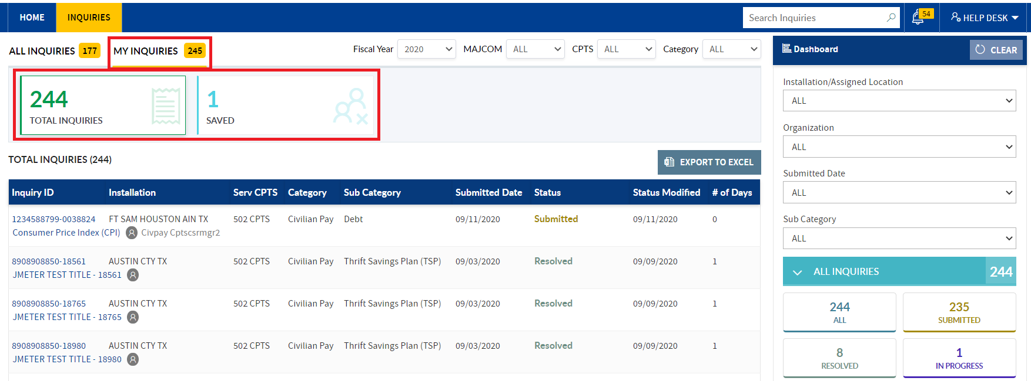

### SAVED TILE:

1. CPTS CSR Manager **Saved/auto saved inquiries** will visible in the respective tile worklist.

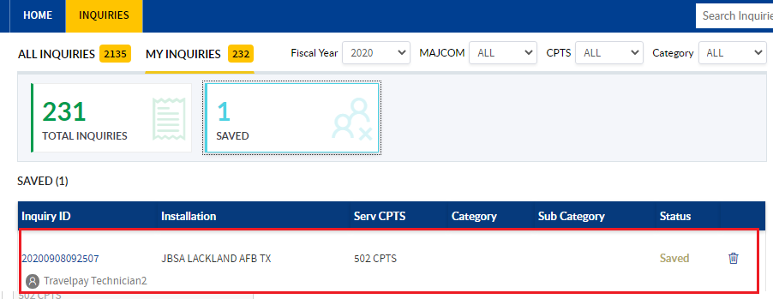

1. CPTS CSR Manager can delete the Saved inquiry, using delete icon in the worklist.

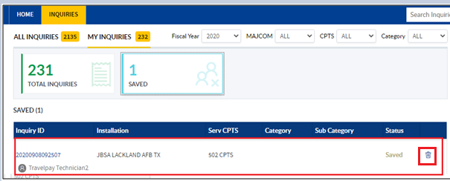

**Note:** For Dashboard actions, please refer to Total Inquiries Tile- Dashboard section steps

# INQUIRY REQUEST DETAILED VIEW PAGE

Below features will be visible to the **CPTS CSR Manager** in the Inquiry detailed view page:

a) **Inquiry ID**- Category name

b) **Priority** of the inquiry will display.

c) **Customer action required**- To have some more info from Customer

c) **Assign To button**- To self-assign the inquiry/ assign to another Manager

d) **Elevate button**- To elevate the inquiry to CPO / AFIMSC

e) **Resolve button**- To Resolve the inquiry.

(**Note:**In order to resolve the inquiry, Inquiry status="CPTS CSR Manager"& should be assigned to self)

f) **Cancel Inquiry**- To Cancel the inquiry on behalf of Customer

g) **Back button**- To navigate to the Inquiries home page.

h) **Inquiry Status section**- updates/details about inquiry status.

i) **Inquiry Details section** with Expand All link.

**Expand all link**-To expand all the sections in the Inquiry Details section

j) **Discussion section**- to discuss with the Customer, other CPTS CSR Manager, CPO, CPTS CSR, AFIMSC, SAF FMF with **Customer and Internal Tags**.

k) **Files section**- CPTS CSR Manager can add/view/Delete/Download All the files from the Files section.

l) **Team Member section**-To add/Delete the Team members.

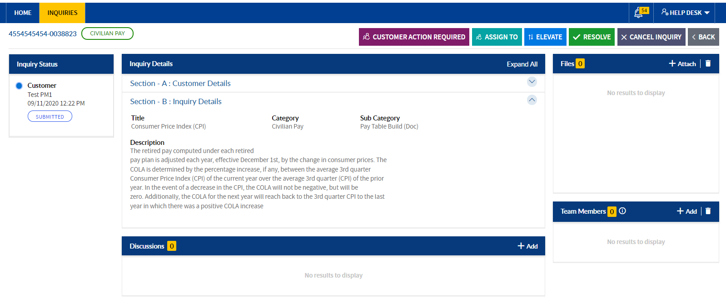

## ADD DISCUSSION

1. Discussions section will be visible to **CPTS CSR Manager** below the Inquiry details section.

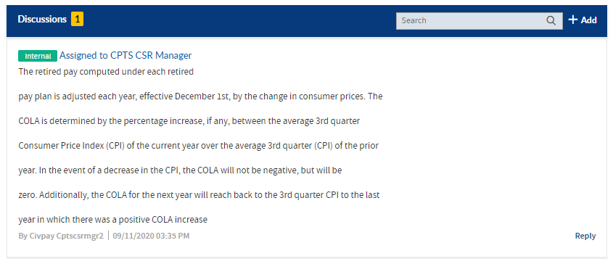

1. **CPTS CSR Manager** can use the discussions section to post questions, information required from the **Customer/CPTS CSR /CPTS CSR Manager**.
2. Click the Add icon in the discussions section, popup comes up with fields

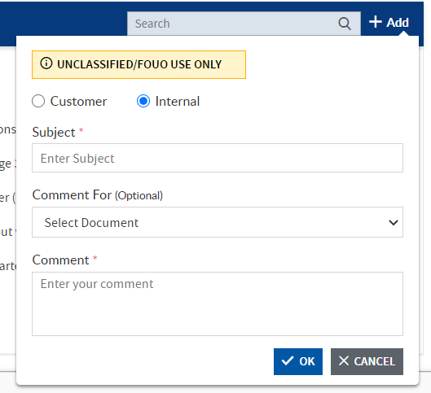

1. Select the Customer radio button. Enter Subject in the subject field, select the document from the Comment for dropdown (optional), enter comment &click the **OK button**.

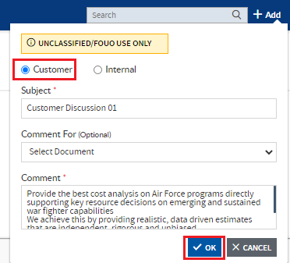

1. Discussion will be posted with customer tag & will be visible in the discussion section with count and reply link.

**Note:Customer comment** will be visible to customer also.

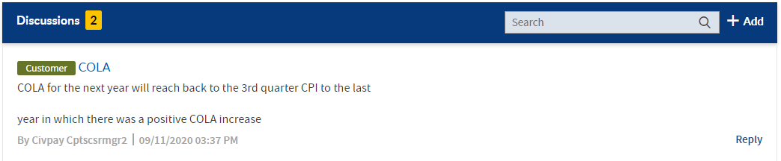

1. Email will deliver for the respective action.

### ADD INTERNAL DISCUSSION

1. Click the **Add icon** in the discussions section, popup comes up with fields

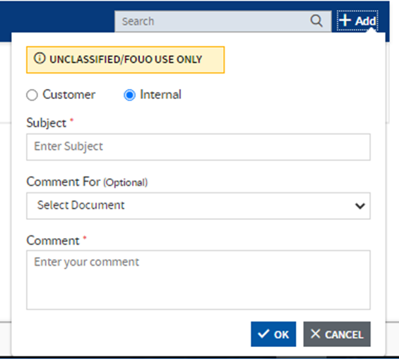

1. By default, internal radio button will be selected in the popup. Enter Subject in the subject field, select the document from the **Comment for dropdown** (optional), enter comment &click the **OK button**.

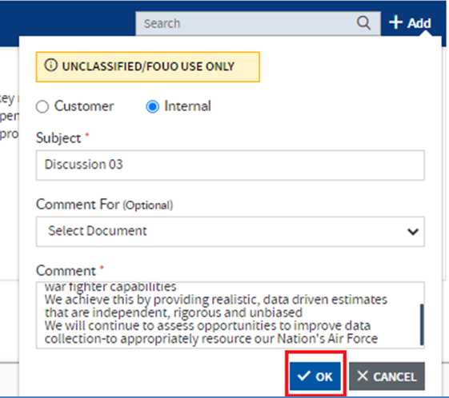

1. Discussion will post with **internal tag**& will be visible in the discussion section with count and reply link.

**Note:**Internal comment will notbe visible to the customer.



### REPLY FOR THE DISCUSSIONS

1. **CPTS CSR Manager** can give reply for the Discussions using Reply link
2. Clicking on **reply link**, reply popup will display.

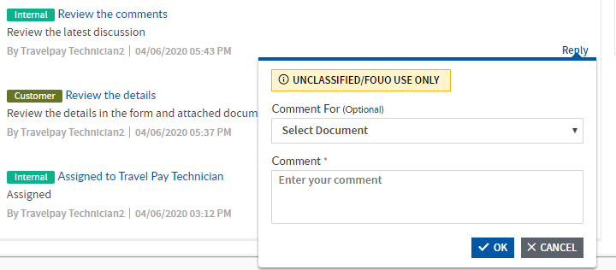

1. Select document from Comment For drop down (optional) & Enter reply in the reply textbox, and click the **OK button**

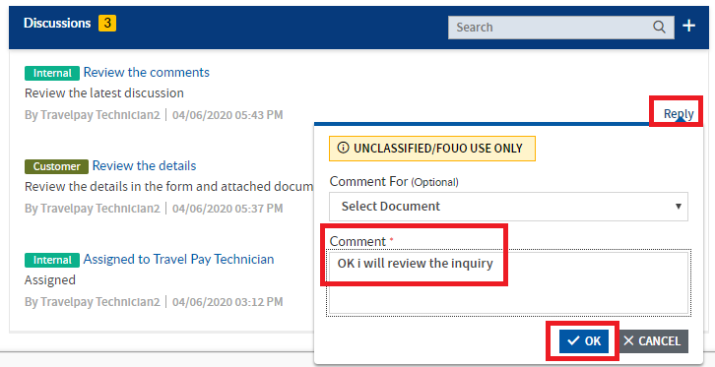

1. **Reply** will post & can see below the main discussion.

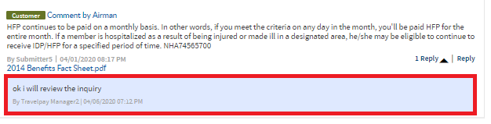

1. **Replies link** with count will be displayed beside the main discussion & replies can be expanded/collapsed for the discussion using the reply expand/collapse icon

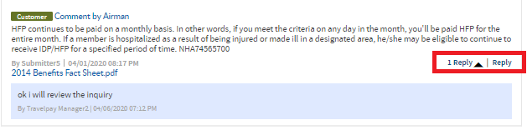

1. Email will deliver for the reply discussion.

### SEARCH DISCUSSIONS

1. Using the search field available in the ‘**Discussions**’ section, CPTS CSR Manager will be able to search the discussion text, by entering the keyword.

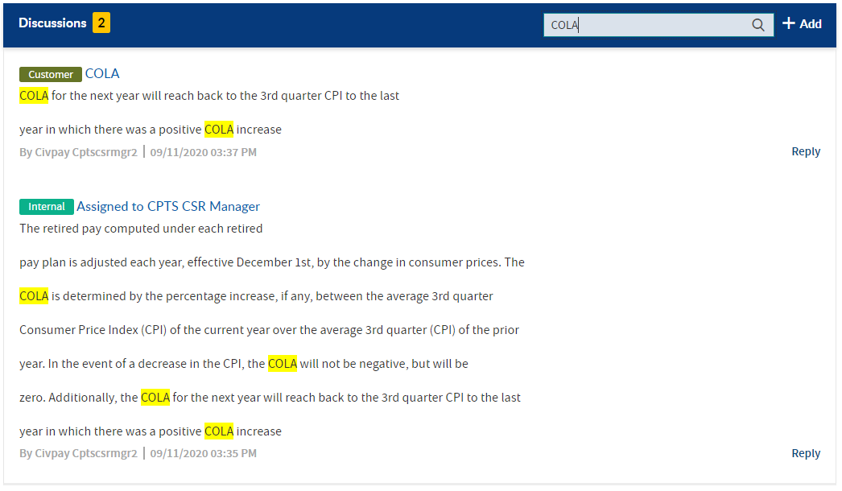

1. Enter keyword in the search field &click the search icon/hit on keyboard enter key, the keywords will be highlighted in yellow
   1. Based on the **search results**, count will be displayed

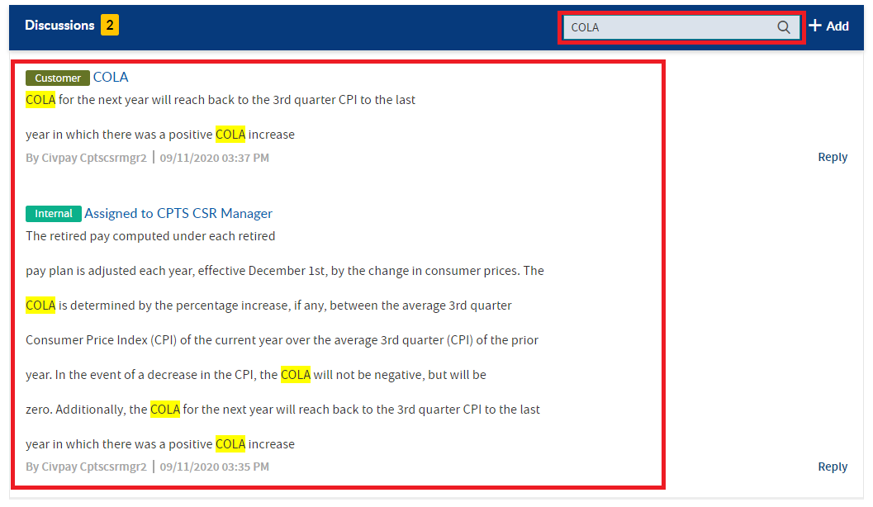

1. **To clear search**, remove the keyword from the search field &click the search icon/hit on keyboard enter key.

## ADD FILES

1. **CPTS CSR Manager** can upload files related to the Inquiry in the Files section

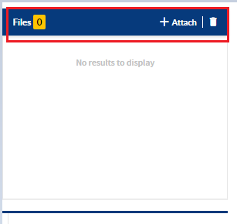

1. Click the **Attach files icon** to add new file

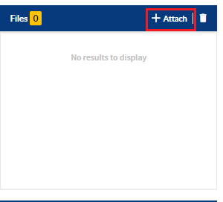

1. Add a File popup comes up, browse file from local drive using **‘Drag/ Choose file’** button

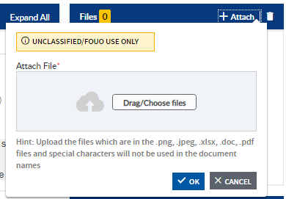

1. Choose a relevant file when popup comes up, select file &click the Open button

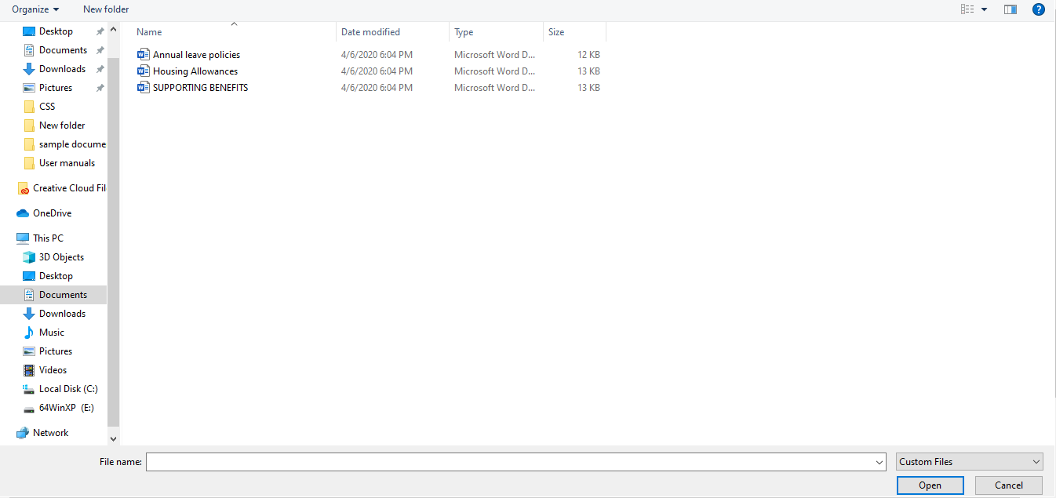

1. Select relevant file, click the OK button to upload the file

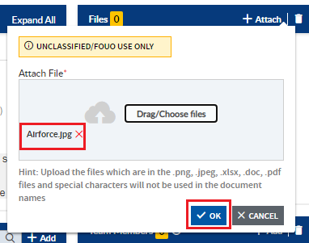

1. File will upload in the Files section, along with submitted& submitted by details, file count will display besides the **Files** heading.

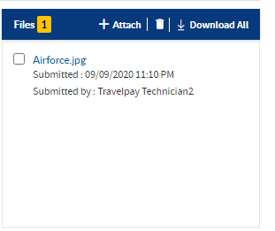

1. Email will deliver to the respective action.

### DOWNLOAD DOCUMENT FROM THE FILES SECTION

1. Click the File name to **download the copy of file** to the local system [can download file uploaded by other users & after making changes in the file, CPTS CSR Manager can upload the file again in the files section]

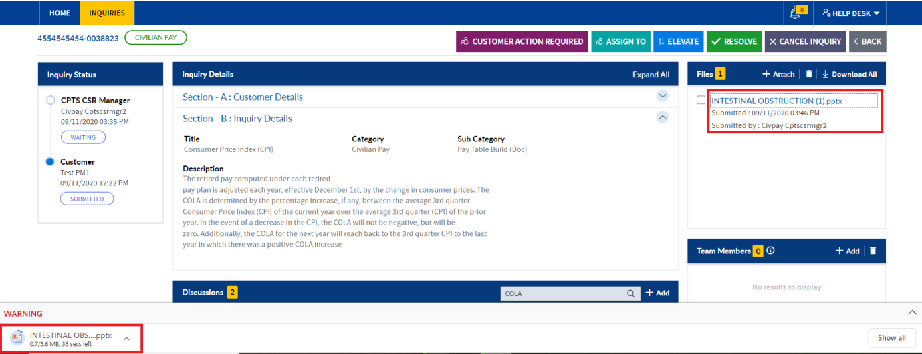

1. **Email** will deliver to the respective action.

### DELETE FILE

1. **CPTS CSR Manager** can delete self-added file from the files section using **delete icon**
2. Select the file to delete and click the **delete icon**

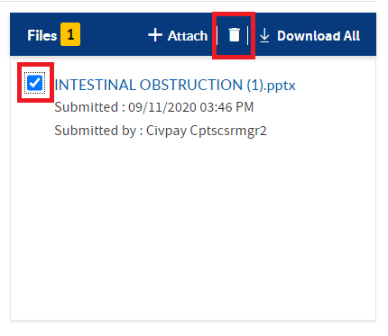

1. **Confirmation pop** up will be displayed, click the OK button

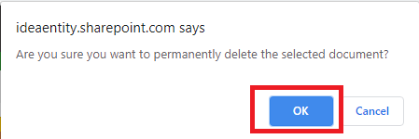

**Note:**To delete multiple documents at once, select multiple checkboxes

1. File will be deleted from the files section &files count will decrement accordingly



1. File delete email will deliver.

### DOWNLOAD ALLFILE

1. Click on **Download all**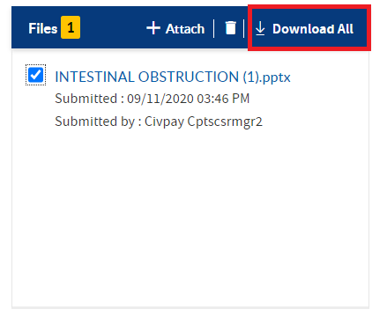
2. Click the **Download all** to download the copy of files to the local system.

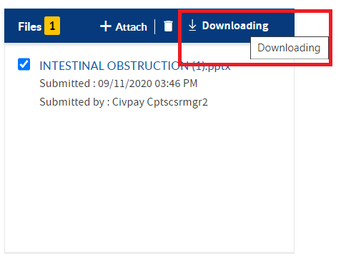

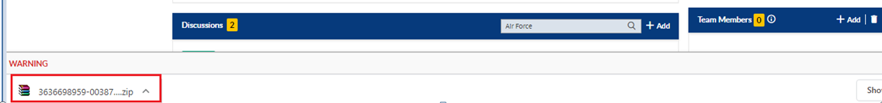

## ADD TEAM MEMBER

1. **CPTS CSR Manager** can add the Team Member using Add button

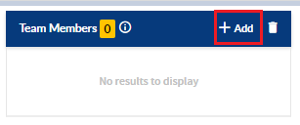

1. Add Team member popup will display, enter the name, user names in the dropdown from the Active directory. **Click the Ok button**

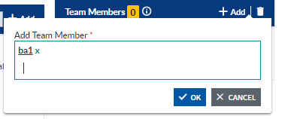

**Note:** Select multiple users by entering multiple user names

1. Added Team Member will be displayed in the respective section.

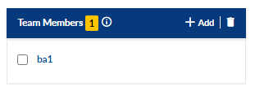

### DELETE TEAM MEMBER

1. Select user **names** to be deleted using check box.

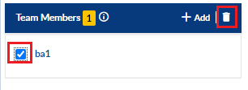

1. Click the **Delete icon**.
2. Confirmation popup will display. Click the **Ok button**

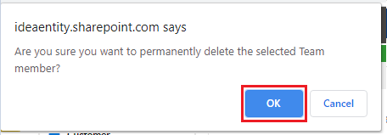

1. **Deleted Team member** will not be visible in the team members section

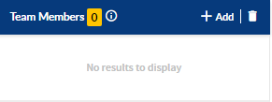

1. Deleted Team member mail will deliver.

# CUSTOMER ACTION REQUIRED

CPTS CSR Manager can perform Customer action required to an inquiry using the Customer action required button.

1. Customer action required button will be visible to Manager if inquiry is **submitted status/Reopened/Assign To** the respective Manager

**Steps to perform the Customer action required for an inquiry**

1. Navigate to inquiries page by clicking on inquiries tab in menu bar or click the **Active tile** in the **page**

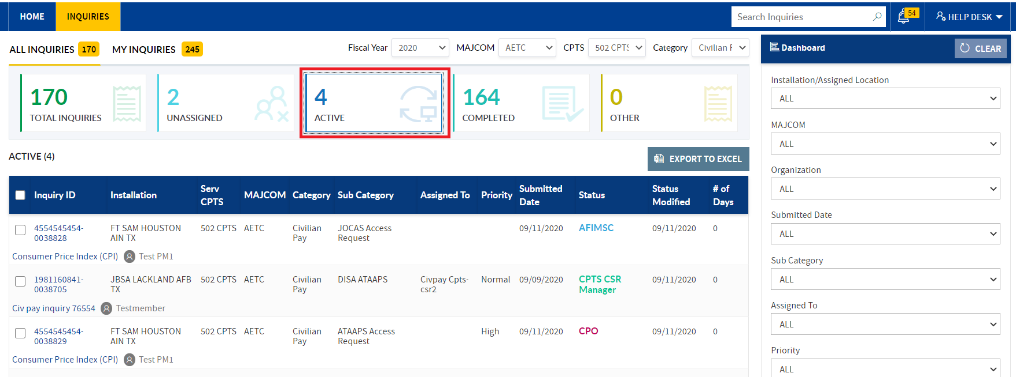

1. In All Inquiries tab gird- Active Tile will be highlighted. In Dashboard section **click the Assigned to Me status.**

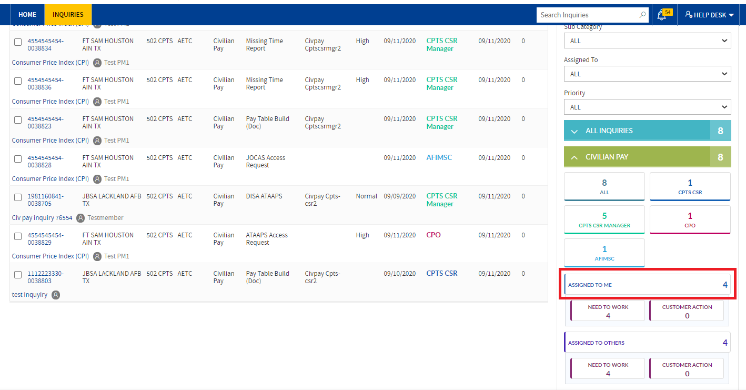

1. Inquiries assigned to respective **Manager** User will be filtered in the **Active tile** work list. Click the inquiry id or title.

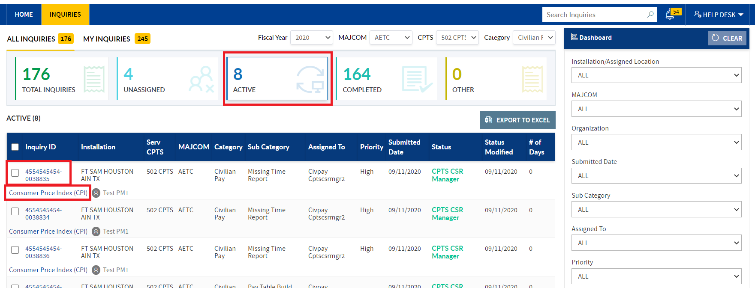

1. Page navigates to inquiry detailed view page, click the **Customer action required button**

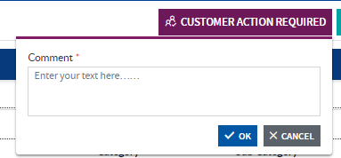

1. Popup comes up with comment field
2. Enter comment in the **comment field** & click the **OK button**

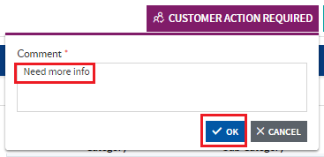

1. The inquiry will be Action required, and status of the inquiry will change to waiting at customer
   1. The status will be visible in the Inquiry Status section
   2. The **comment** will be visible in the discussions section with customer tag; comment with customer tag will be visible to all the users
   3. After performing **Customer action required** action Resolve and Cancel Inquiry should hide and Return to **CPTS** should be displayed

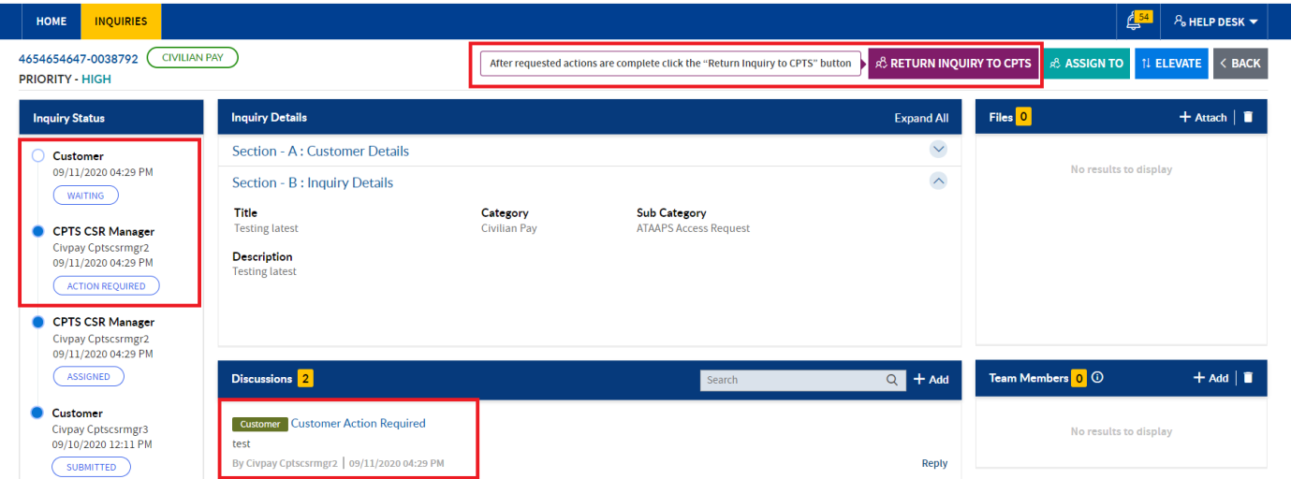

# RETURN INQUIRY TO CPTS

**CPTS CSR Manager** can perform Return Inquiry to **CPTS** action to an inquiry using the Return Inquiry to CPTS button based on the intimation by customer.

1. Return Inquiry to **CPTS button** will be visible to **Manager**, after performing **Customer action required**, if inquiry is assign to the Manager
2. Click the Return Inquiry to **CPTS button**
3. Popup comes up with comment field

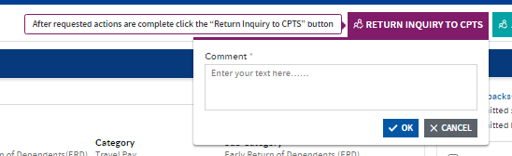

1. Enter comment in the comment field & click the **OK button**

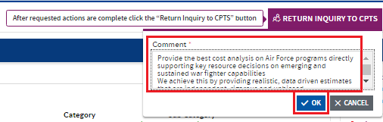

1. The inquiry will be Returned to **CPTS**, and status of the inquiry will change to waiting at Manager
   1. The status will be visible in the Inquiry Status section
   2. The **comment** will be visible as **reply comment** for the Customer action required discussion in the discussions section
   3. After performing Return Inquiry to CPTS action **Customer action required, Assign To, Elevate, Resolve and Cancel Inquiry** will display

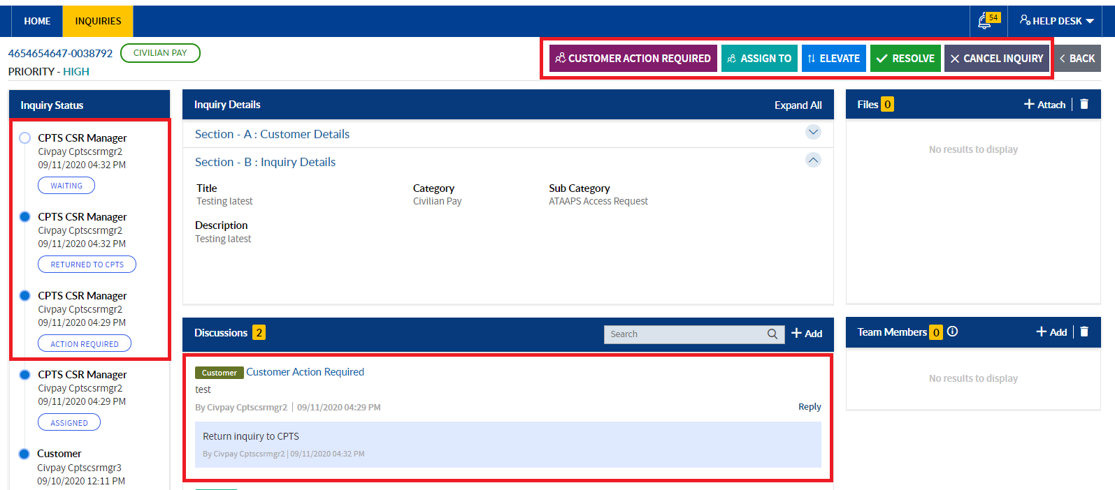

# RESOLVE INQUIRY

**CPTS CSR Manager** can resolve an inquiry using the resolve button. Below are the scenarios, where the resolve button will be visible to **CPTS CSR Manager** to resolve the inquiry

1. Resolve button will be visible to Manager if inquiry is submitted/reopen status &assign to the Manager.

**Steps to resolve an inquiry**

1. Navigate to inquiries page by clicking on inquiries tab in menu bar or click the Active tile in the landing page
2. In All Inquiries tab gird- **Active Tile** will be highlighted. In Dashboard section click the **Assigned to Me** status.



1. Inquiries assigned to respective Manager User will be filtered in the Active tile worklist .Click the inquiry id or title.



1. Page navigates to **inquiry detailed view page**, click the **Resolve button**

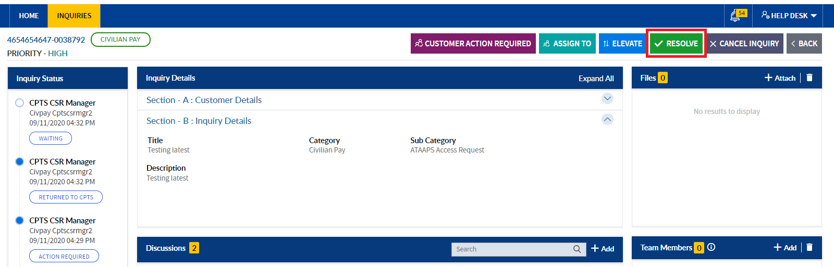

1. **Popup comes** up with comment field

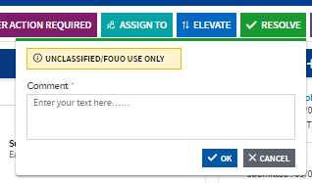

1. Enter comment in the **comment field & click the OK button**
2. The inquiry will be resolved, and status of the inquiry will change to **Resolved**
   1. The status will be visible in the Inquiry Status section as **Resolved**
   2. The resolved comment will be visible in the **discussions section** with customer tag; **comment with customer tag** will be visible to all the users

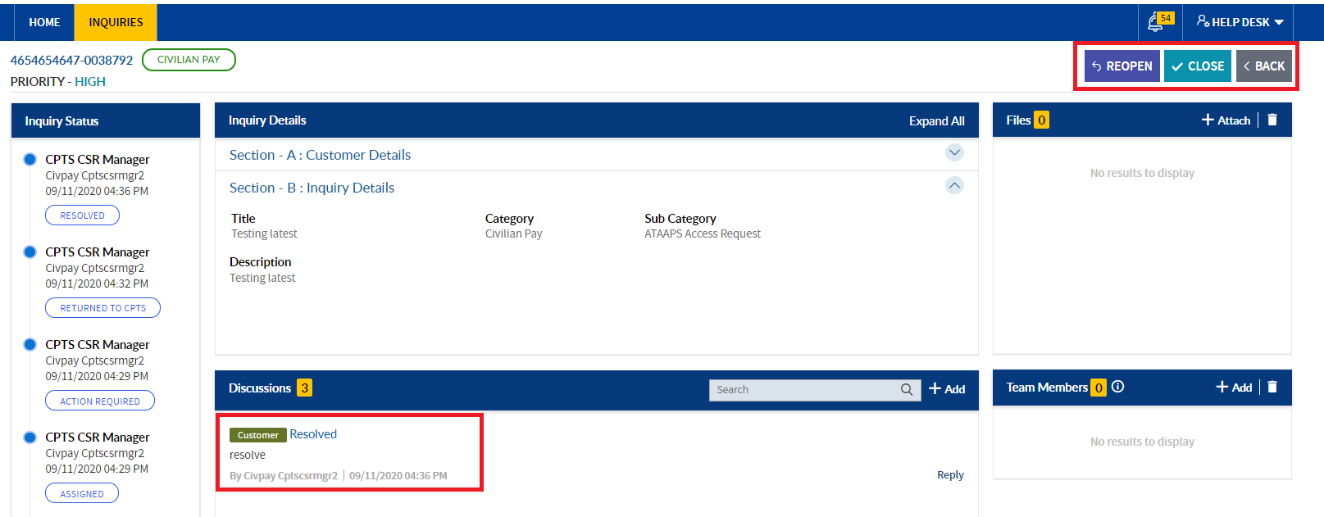

1. **Reopen and Close buttons** will be visible for **Manager**.
2. Email will deliver for respective action.

# CLOSE THE INQUIRY

**CPTS CSR Manager** can close the resolved inquiry using close button. Customer can close the inquiry, in case customer do not have access to the system, on behalf of customer, Manager can close the inquiry on intimation from customer.

1. Navigate to inquiries page by clicking on inquiries tab in menu bar or click the **Completed Tile in landing page**
2. In Inquiries home page under All Inquiries tab worklist, click the **Completed tile**

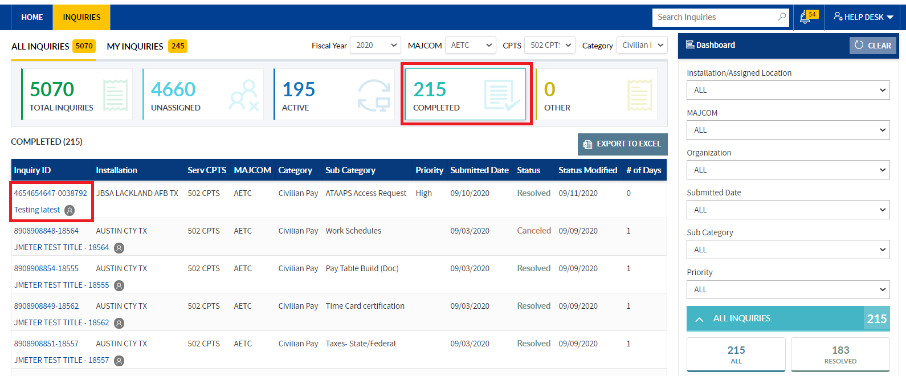

1. Click the inquiry title or inquiry ID with status as **“Resolved”**

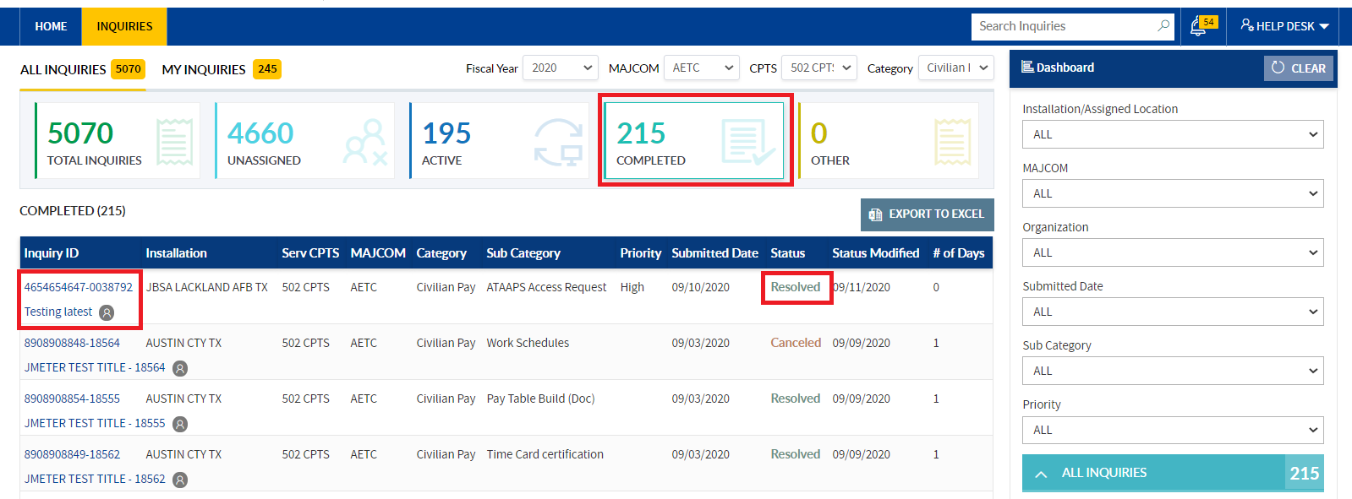

1. Page navigates to inquiry detailed view page, click the **Close button**

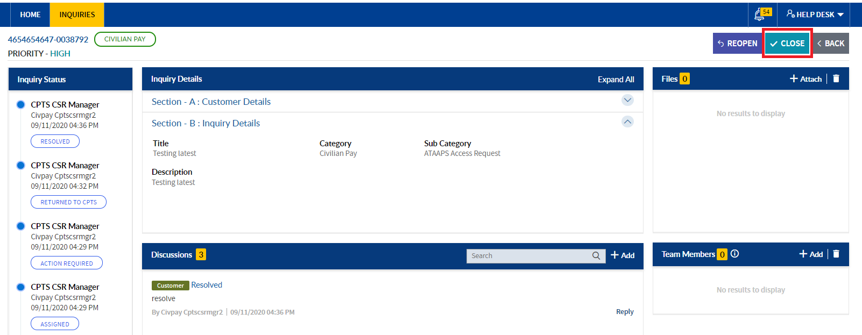

1. Popup comes up with comment field
2. Enter comment in the comment field &click the **OK button**

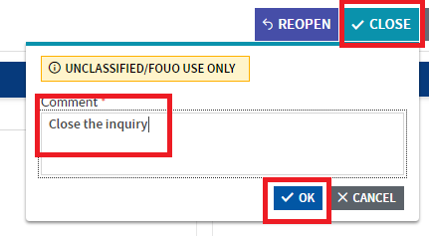

1. The inquiry will be closed, and status of the inquiry will change to **Closed**
   1. The status will be visible in the Inquiry Status section as **Closed with details**
   2. The closed comment will be visible in the discussions section with customer tag; comment will be visible to all the users

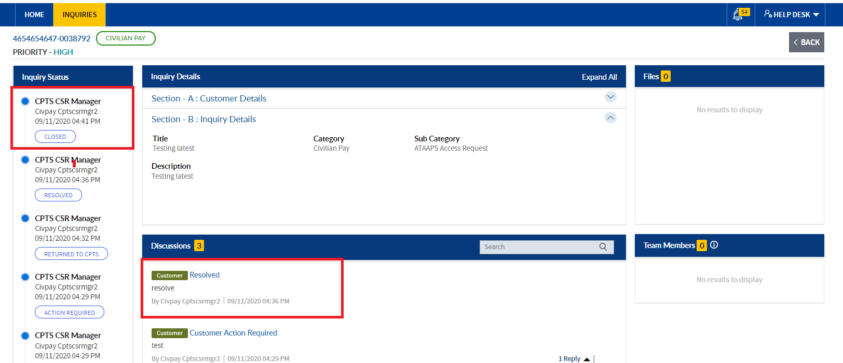

1. The closed inquiry will be visible in **completed/total inquiries tile**
2. Email will deliver for respective action.

# REOPEN THE INQUIRY

CPTS CSR Manager can reopen the resolved inquiry using **Reopen button. Customer can reopen the inquiry**, in case customer do not have access to the system, on behalf of customer Manager can reopen the inquiry on intimation from customer.

1. Navigate to inquiries page by clicking on inquiries tab or click the active tile in landing page.
2. In Inquiries home page under All Inquiries tab worklist, Active tile will be highlighted. Click the Completed tile.



1. Click the inquiry title or inquiry ID with status as **“Resolved”**



1. Page navigates to inquiry detailed view page, click the **Reopen button.**

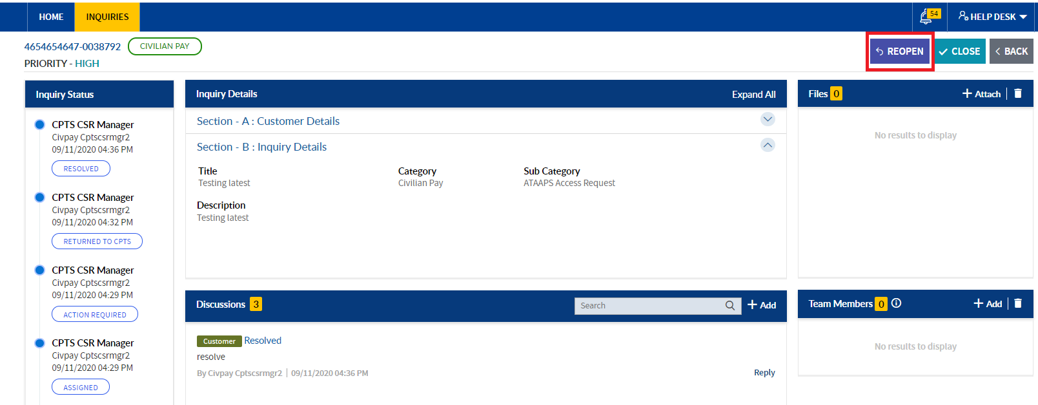

1. Popup comes up with comment field
2. Enter comment in the comment field &click the **OK button**

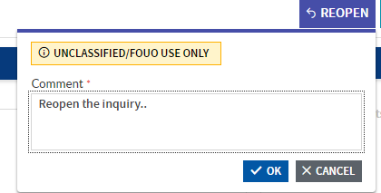

1. The inquiry will be **Reopened**, and status of the inquiry will change to **Reopened**
   1. The status will be visible in the Inquiry Status section as **Reopened** with reopen details
   2. The **Reopened comment** will be visible in the **discussions section** with Customer tag; comment will be visible to all the users
   3. **Customer action required,**  **Assign To, Elevate, Resolve and Cancel Inquiry** will be visible.

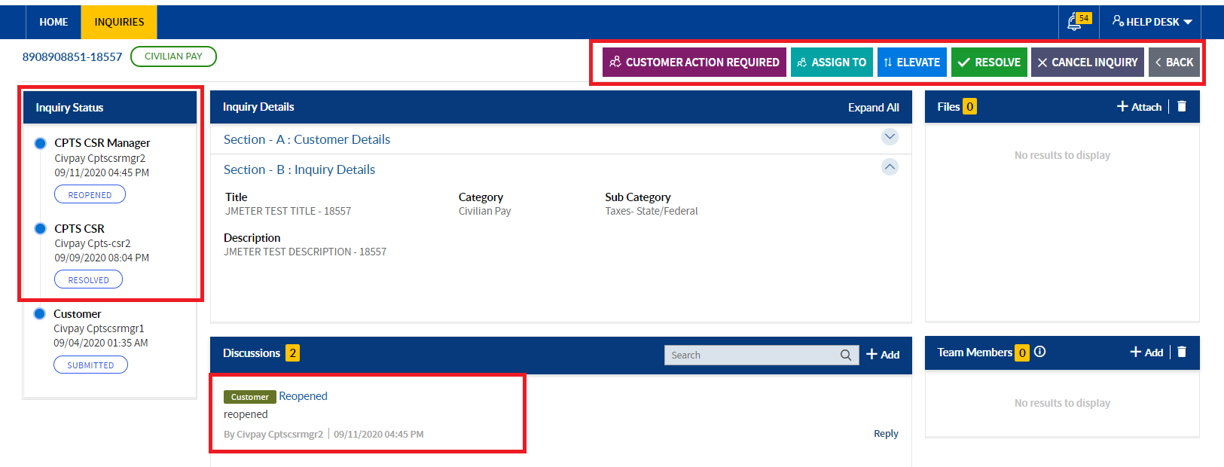

1. The reopened inquiry will be visible in **Unassigned tile**

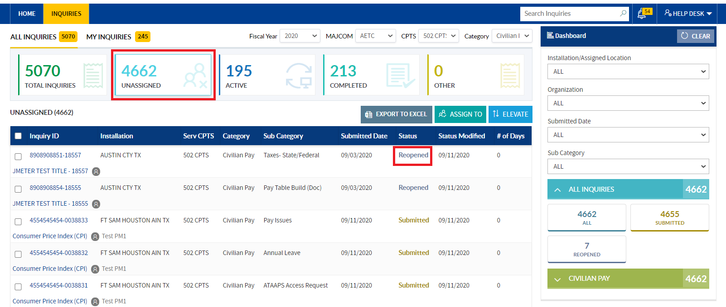

1. Email will deliver for respective action.

# CANCEL ACTION

CPTS CSR Manager can cancel the inquiry using **Cancel Inquiry button**. Customer can Cancel the inquiry, in case customer don’t have access to the system, on behalf of customer Manager can cancel the inquiry on intimation from customer

1. From Unassigned tile/total inquiries tile/active tile, click the Inquiry ID/Title

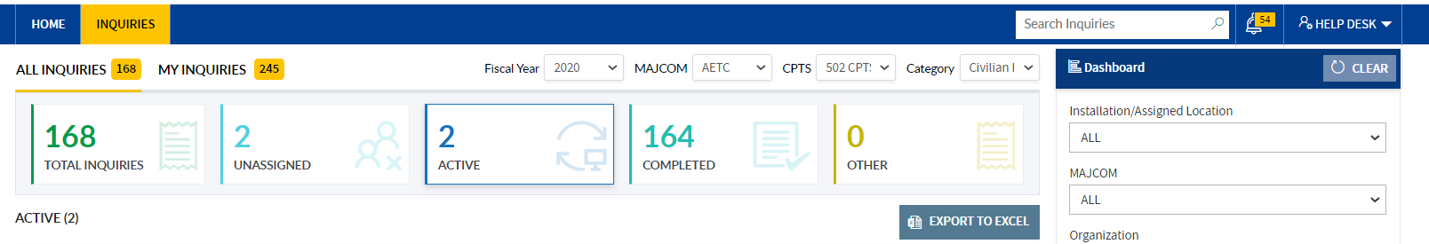

1. Page will navigate to Inquiry detailed view page.

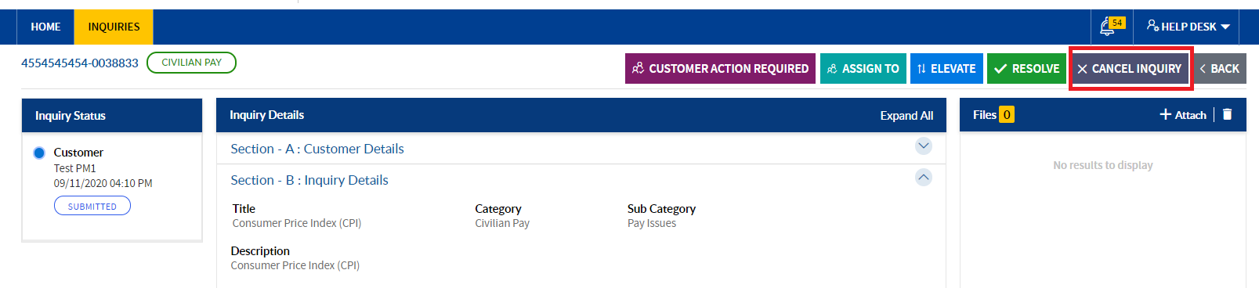

1. Click the **Cancel Inquiry button**
2. Popup will display

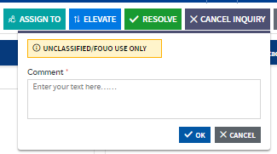

1. **Enter/copy & paste** the comment, click the Ok button

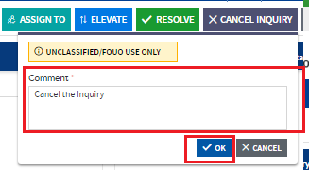

1. Inquiry will **cancel, and cancelled** comment will display in the Discussions section with Customer tag.

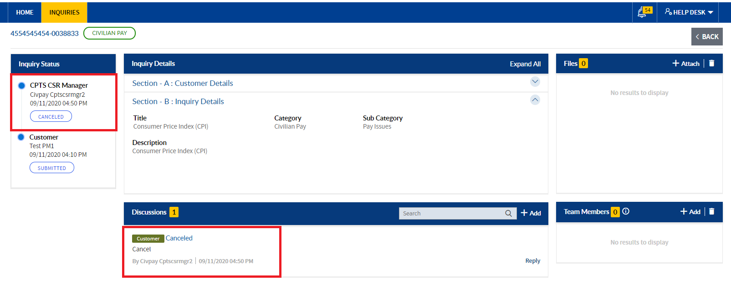

1. Email will deliver for respective action.

# DUAL ROLE:

**CPTS CSR Manager can perform dual roles in different categories but within the CPTS.**

**Note:**CPTS CSR Manager should add in the respective category Manager role group.

>> In the Inquiries home page, under Category dropdown, CPTS CSR Manager can view the respective category names.

Based on the category selection, inquiries will be displayed in the respective tiles. And follow the above steps to **Customer Action required**/ **Assign To/Elevate/Resolve/Close/Reopen /Cancel Inquiry** the inquiries as Manager.